
Alameda County Safe Routes to Schools

Golden Sneaker Contest Social Media Toolkit

Social media is a great way to reach students, teachers, and the broader community quickly and frequently. That’s why we have put together this social media toolkit to provide text and graphics for our Alameda County Safe Routes to Schools (SR2S) Program partners to share their excitement about the Golden Sneaker Contest on their organizations’ social media accounts. This toolkit was created for:
- School administrators
- School districts
- Elected officials
- Parents and caregivers
- You!

You can choose which social media image to post based on the Safe Routes to Schools Program theme you want to communicate to your community. Go with what works best for you! As a reminder, the SR2S Program themes are:
- Building community on campus and in classrooms
- Encouraging students to be physically active
- Reducing emissions
- Reducing traffic congestion
- Promoting active and shared transportation
- Increasing safety on our streets
- Improving academic performance

How to Use these Social Media Posts
Heads up!
Some text is highlighted yellow for you to personalize. Remember to change it before posting online!
We’ve put together instructions and posts that you can use to promote the event. When you want to use one, just do the following:
- Download images from this toolkit and save them to your device.
- Log on to your social media site, such as Facebook, X, or Instagram.
- Use text we’ve provided or create your own message into a post or series of posts that includes the #GoldenSneakerContest hashtag.
- Upload the image you saved to your device to accompany your text.

- Post away!
Post 1
Theme: Build community on campus and in classrooms | When to post: Anytime now until Friday, January 30th
Who should post this? Elected officials, school administrative staff of participating schools | Post content: Looking for a way to build community at your school? Join the #GoldenSneakerContest! Classrooms work together to walk, bike, roll, take transit, and carpool to school to win the coveted Golden Sneaker trophy in this @AlamedaCoSR2S event. Join in the fun by registering here: bit.ly/4oXNa3I

Facebook graphic  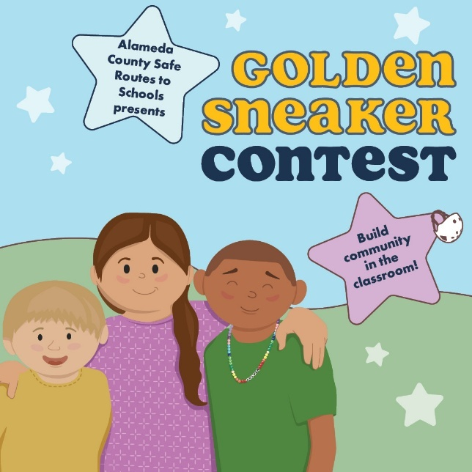 | X/Twitter graphic  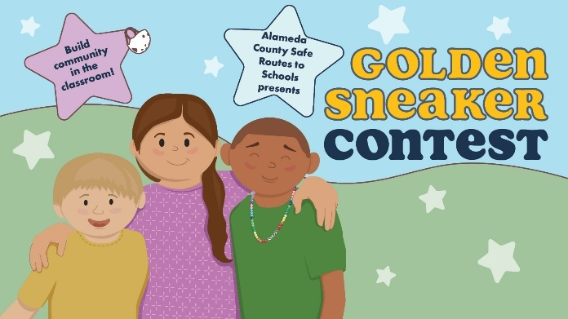 | Instagram graphic  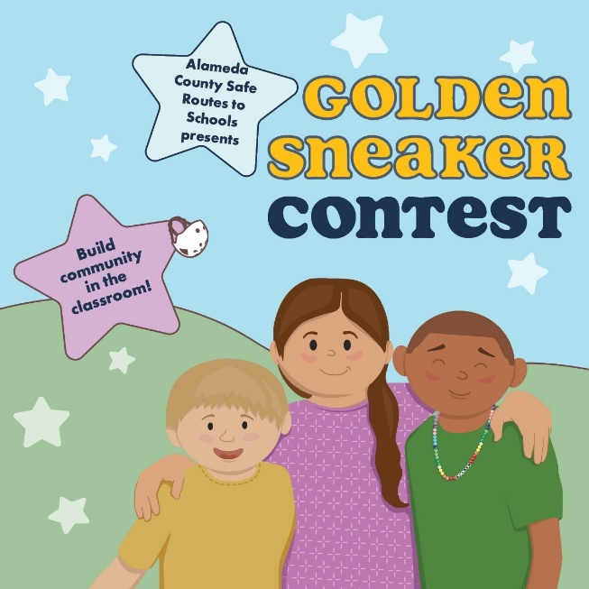


Post 2
Theme: Promote active and shared transportation | When to post: Anytime now until Friday, January 30th
Who should post this: Elected officials | Post content: I’m overjoyed to support active transportation through the #GoldenSneakerContest, where classrooms work together to walk, bike, roll, take transit, or carpool to win the Golden Sneaker trophy. Show your support for this @AlamedaCoSR2S event and register here: bit.ly/4oXNa3I

Facebook graphic  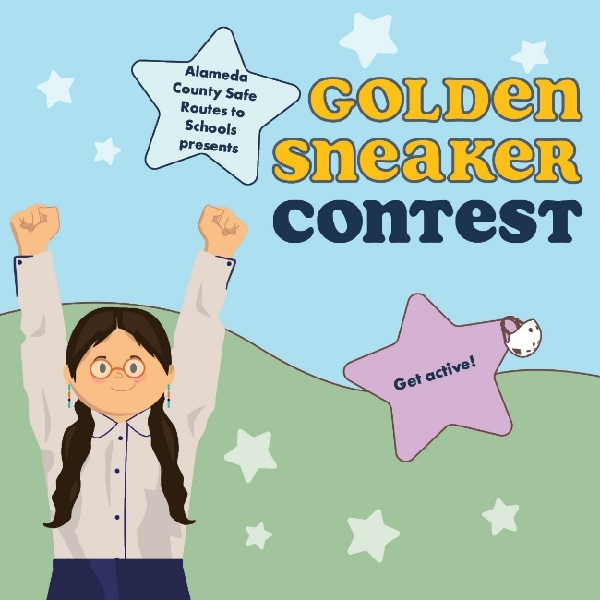 | X/Twitter graphic  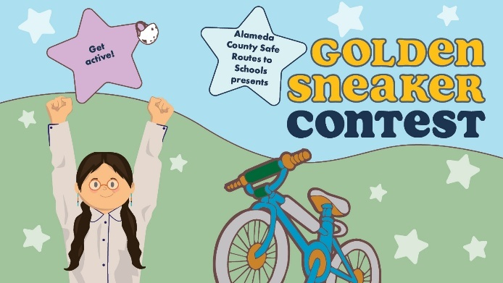 | Instagram graphic  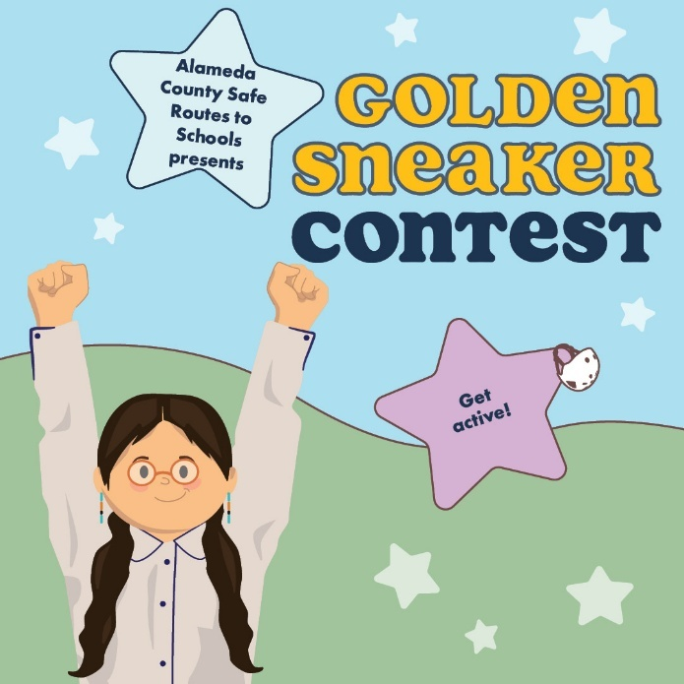

Post 3
Theme: Promote active and shared transportation | When to post: Anytime now until Monday, March 2.
Who should post this: Anyone! | Post content: Jumpstart a new healthy habit with the #GoldenSneakerContest!! Join your school community (March 2 – 13) and walk, bike, roll, carpool, or take shared transit to school to compete! The benefits are endless! @AlamedaCoSR2S

Facebook graphic  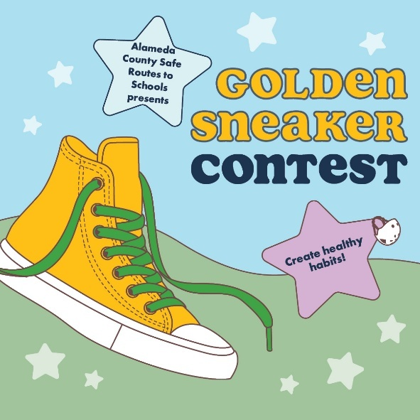 | X/Twitter graphic  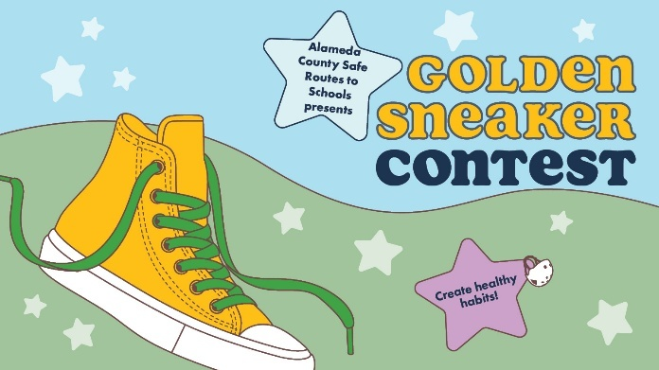 | Instagram graphic  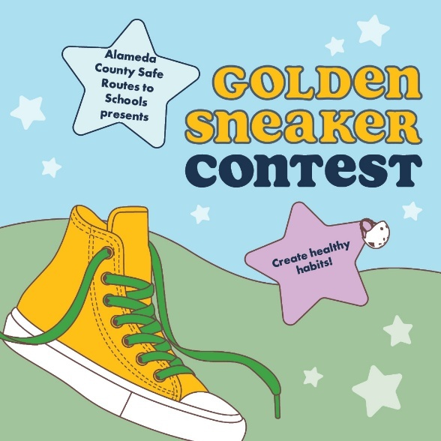

Post 4
Theme: Encourage students to be physically active | When to post: Between Monday, March 2nd and Friday, March 13th.
Who should post this: Anyone! | Post content: Did you know walking can help children achieve the CDC’s recommended amount of 60 minutes of daily exercise? The #GoldenSneakerContest is a great way to get that physical activity in! Let’s get moving and join this @AlamedaCoSR2S event! 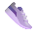


Facebook graphic  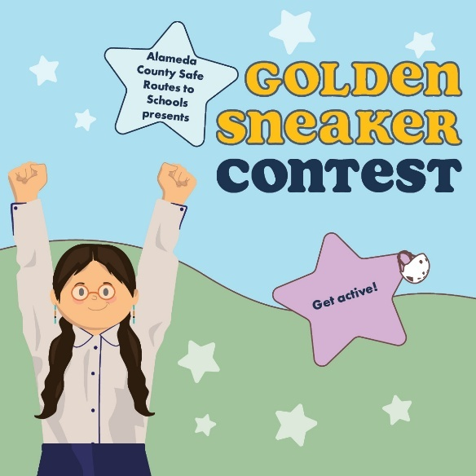 | X/Twitter graphic  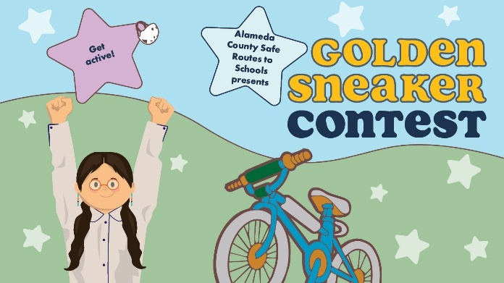 | Instagram graphic  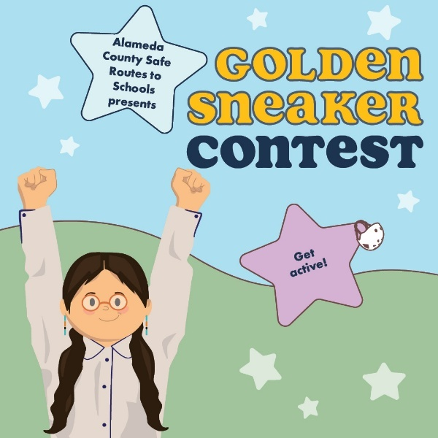


Post 5
Theme: Reduce pollution | When to post: Between Monday, March 2nd and Friday, March 13th.
Who should post this: Anyone! | Post content: I’m [select: walking, rolling, using public transit, or carpooling] for the @AlamedaCoSR2S #GoldenSneakerContest because it keeps us healthy by reducing air pollution around my school — and it’s fun! Join the contest, March 2 – March 13.

Facebook graphic  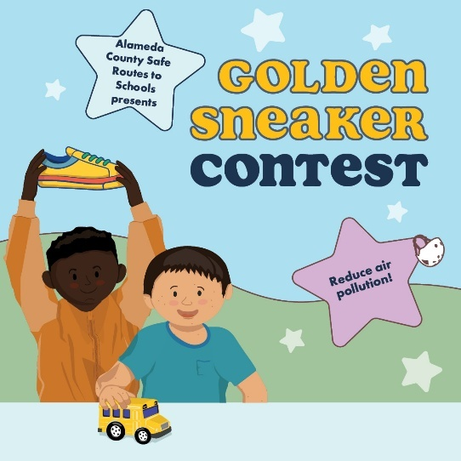 | X/Twitter graphic  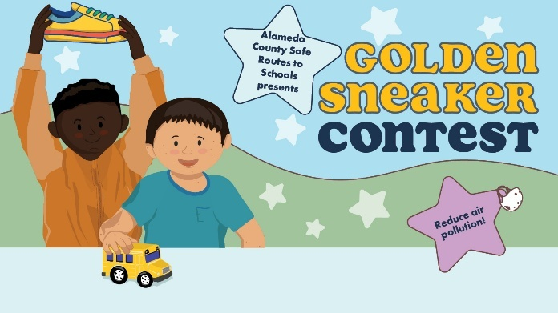 | Instagram graphic  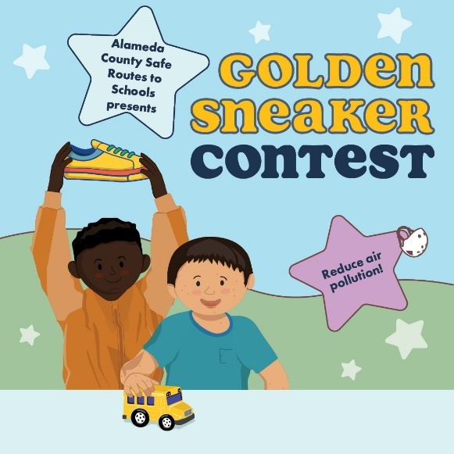

Post 6
Theme: Reduce traffic congestion | When to post: Between Monday, March 2nd and Friday, March 13th
Who should post this: Anyone! | Post content: Join the many schools in Alameda County that are choosing not to wait in drop-off traffic and instead are walking, rolling, or using shared transit to school during the #GoldenSneakerContest. @AlamedaCoSR2S

Facebook graphic  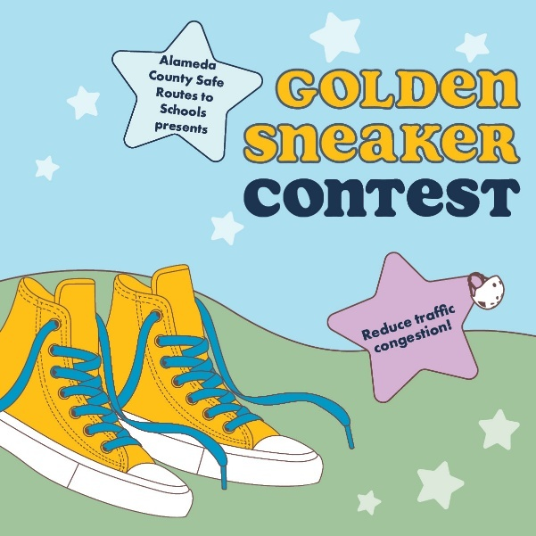 | X/Twitter graphic  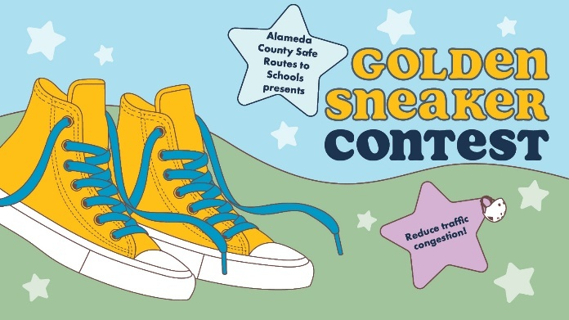 | Instagram graphic  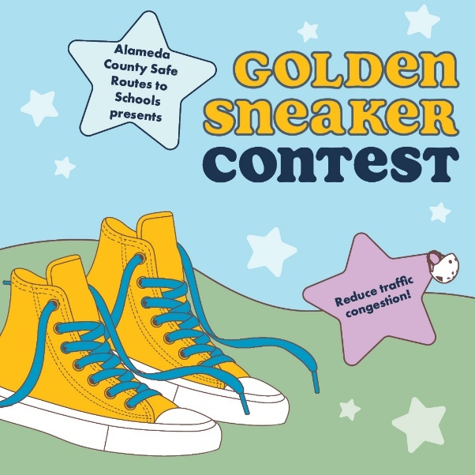



Post 7
Theme: Increasing safety on our streets | When to post: Anytime now until Friday, March 13.
Who should post this: Anyone! | Post content: I’m [walking, rolling, using shared transit, or carpooling] for the @AlamedaCoSR2S #GoldenSneakerContest because fewer cars = fewer crashes and make our school streets safer. Join the fun March 2 – March 13!
Facebook graphic  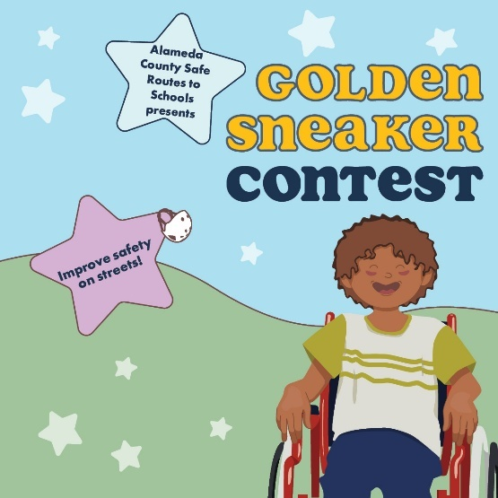 | X/Twitter graphic  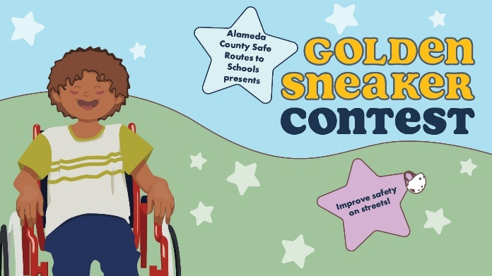 | Instagram graphic  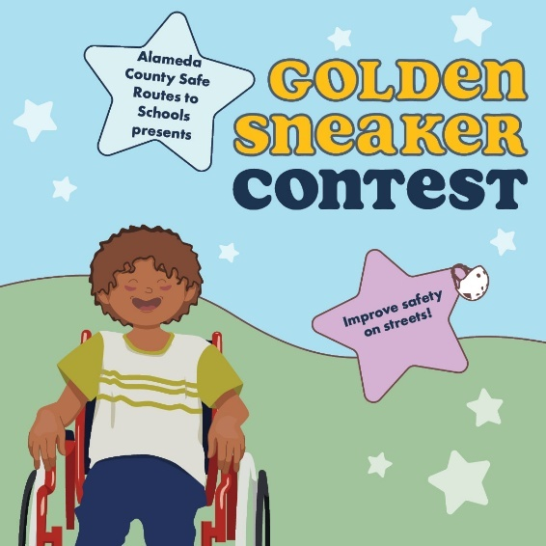


Post 8
Theme: Improving academic performance | When to post: Anytime between Monday, March 2 and Friday, March 13.
Who should post this: Families and caregivers | Post content: My family is [walking, rolling, using shared transit, or carpooling] for the @AlamedaCoSR2S #GoldenSneakerContest because physical activity before school boosts academic performance and supports mental health. Join the contest now until March 13!


Facebook graphic  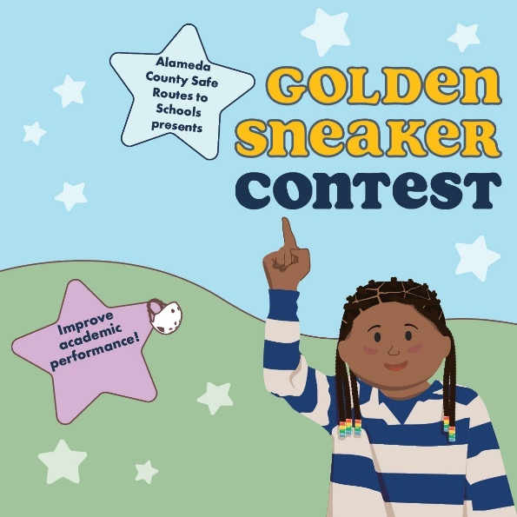 | X/Twitter graphic  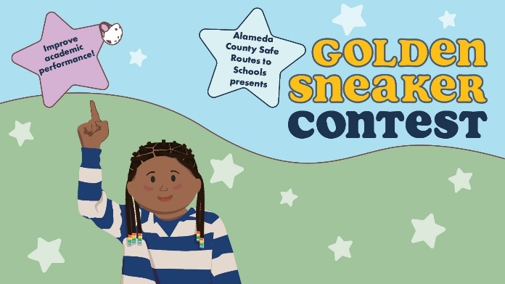 | Instagram graphic  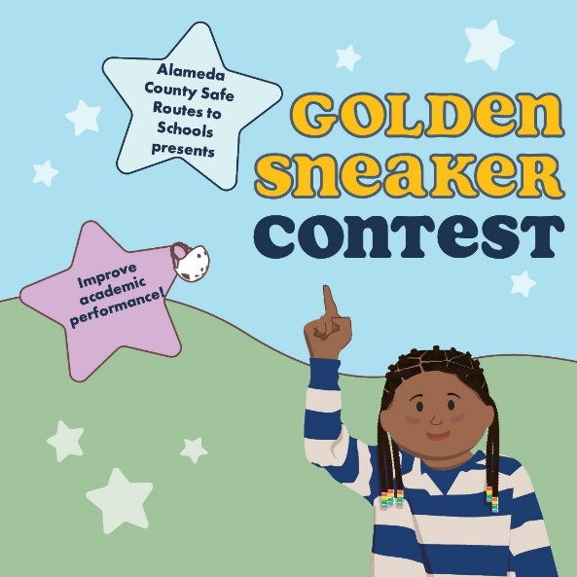


Post 9
Theme: Reduce pollution | When to post: Between Monday, March 2nd and Friday, March 13th
Who should post this: Anyone! | Post content: Reducing vehicle emissions is critical to keeping our air and planet clean! That’s why our school community is participating in @AlamedaCoSR2S’s #GoldenSneakerContest. Together, we can keep ourselves and our planet healthy 

Facebook graphic  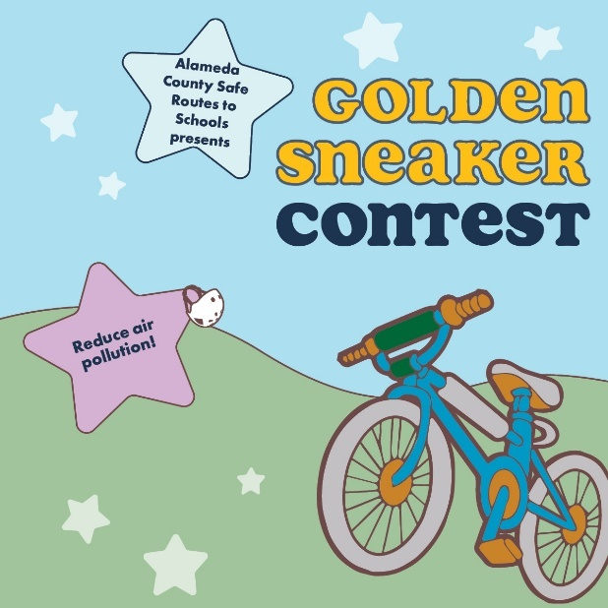 | X/Twitter graphic  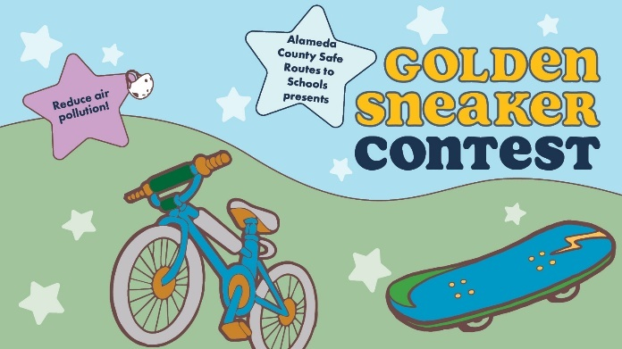 | Instagram graphic  