Walking School Bus

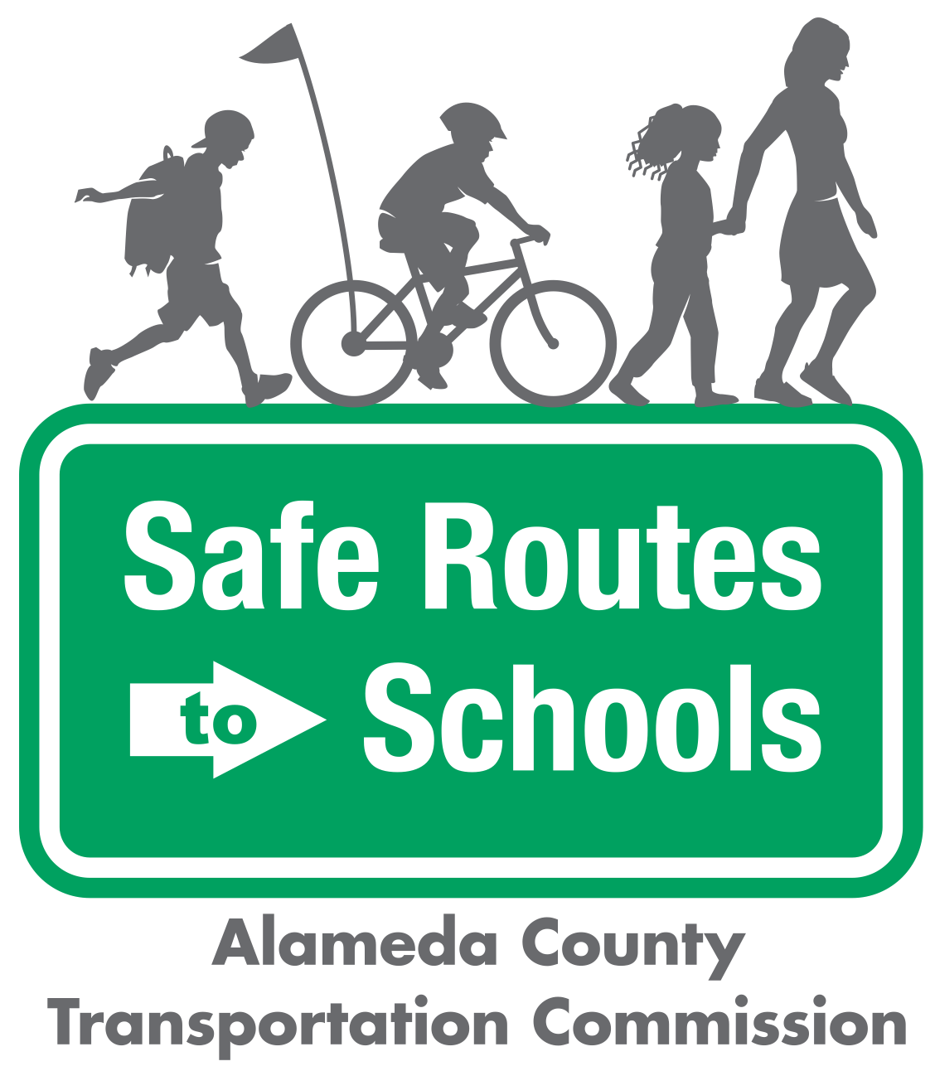

Questions? ¿Preguntas? Contact/Contacto:

info@alamedacountysr2s.org

Scenario Planning

|  |  |  |  |
| --- | --- | --- | --- |
| |  | | --- | | Scenario | | |  | | --- | | Route Leader response | |
| Imagine a child in the walking school bus tripped and fell on the sidewalk. He has a scraped knee and is crying. |  |
| There is one child in the walking school bus with a lot of energy. She continuously runs ahead of the bus. |  |
| One of the children in the bus is not following proper walking safety rules. He runs out between parked cars and forgets to look left, right, then left again. |  |
| One day, on your normal route, you find construction has started that blocks the entire sidewalk. |  |

|  |  |  |
| --- | --- | --- |
|  | Image result for metropolitan transportation commission, logo no background | *The Alameda County Safe Routes to Schools Program is a program of the Alameda County Transportation Commission (alamedactc.org) and is funded with Alameda County’s local Measure BB sales tax, and regional, state, and federal funds.* |