Bike Train

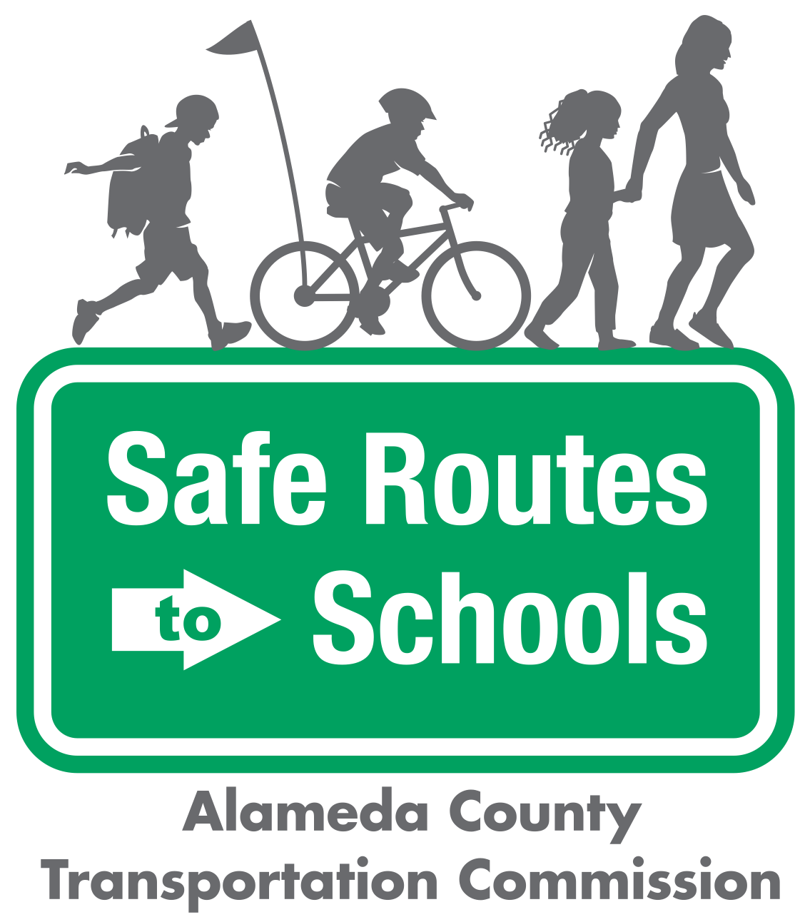

Questions? ¿Preguntas? Contact/Contacto:

info@alamedacountysr2s.org

|  |
| --- |
|  |
| * THEME DAYS: Children and adults can come up with themes that go along with each day of the week. For example, Mondays can be “yellow day” when everyone wears yellow; Tuesdays can be “stripe day” when everyone wears stripes; Wednesdays can be “sports day,” etc. * NAME YOUR BUS: Name your walking school bus group. Solicit input from the students and ask them to vote. * HELMET DECORATING: Have a helmet-decorating party before beginning your Bike Train to get kids excited about wearing their helmets to school. |  |

Game Ideas

|  |  |  |
| --- | --- | --- |
|  | Image result for metropolitan transportation commission, logo no background | *The Alameda County Safe Routes to Schools Program is a program of the Alameda County Transportation Commission (alamedactc.org) and is funded with Alameda County’s local Measure BB sales tax, and regional, state, and federal funds* |