Walking School Bus

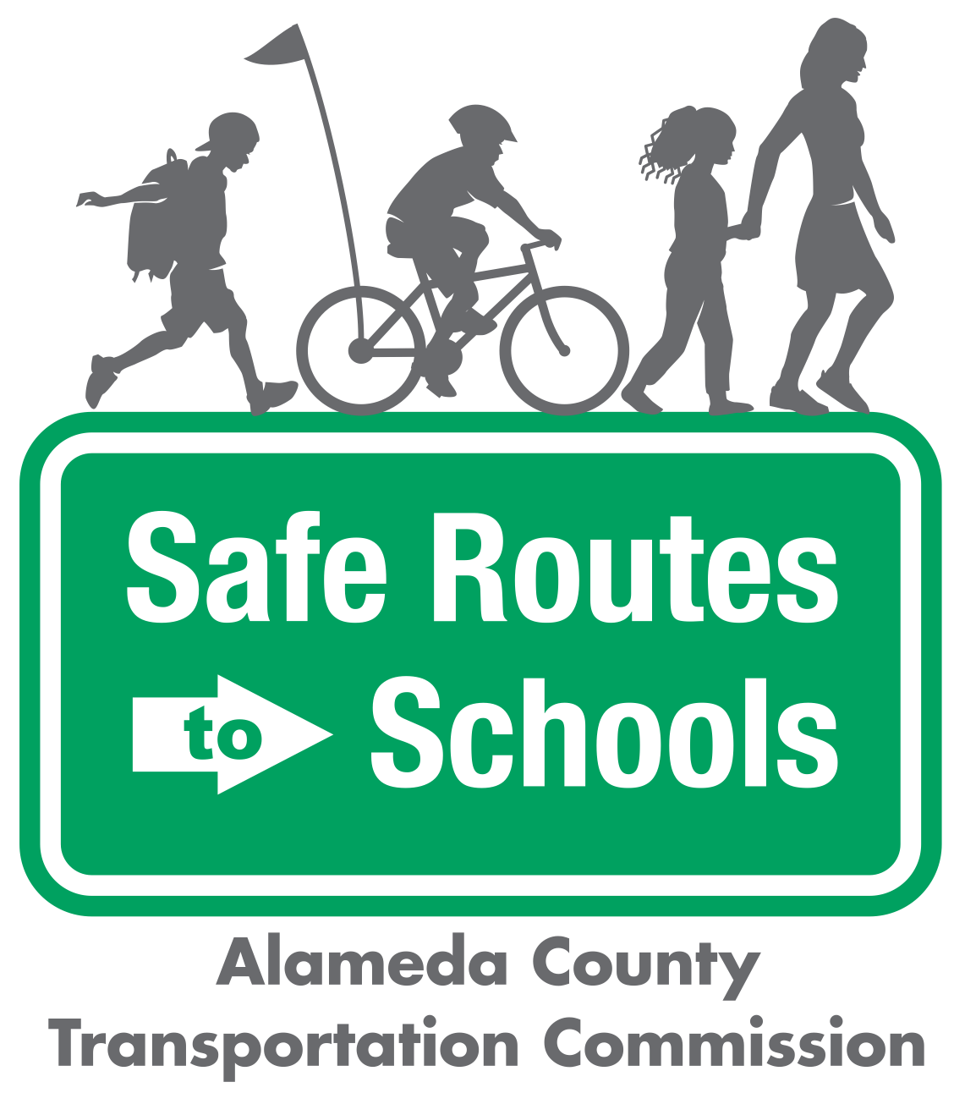

Questions? ¿Preguntas? Contact/Contacto:

info@alamedacountysr2s.org

|  |
| --- |
|  |
| * BE ALERT. Look left, right, then left again before crossing the street. At a four-way intersection, look over your shoulder for cars that may be turning. * LISTEN FOR ONCOMING CARS that may be behind a parked car, tree, or other obstacle. * CROSS AT CORNERS or at a marked crosswalk. This is where drivers expect you. * USE CROSSING SIGNALS CAREFULLY. If the intersection has a walk signal, push the button and wait for the walk signal. Before you cross, check that all drivers have stopped, especially those turning right. * USE EYE CONTACT and hand signals to communicate before crossing. Don’t assume driver see you. * FOLLOW DIRECTIONS from crossing guards and safety patrols. * USE A SIDEWALK WHEN AVAILABLE. If there’s no sidewalk, walk on the road facing oncoming traffic. * WALK WITH AN ADULT, other students, or a buddy, particularly if you are a younger student * DRESS TO BE SEEN. Bright colors are more visible during the day, and light colors are more visible in the evening or at night. Reflective clothing is always a good idea, too! |  |

Safety Tips

|  |  |  |
| --- | --- | --- |
|  | Image result for metropolitan transportation commission, logo no background | *The Alameda County Safe Routes to Schools Program is a program of the Alameda County Transportation Commission (alamedactc.org) and is funded with Alameda County’s local Measure BB sales tax, and regional, state, and federal funds.* |