Join the

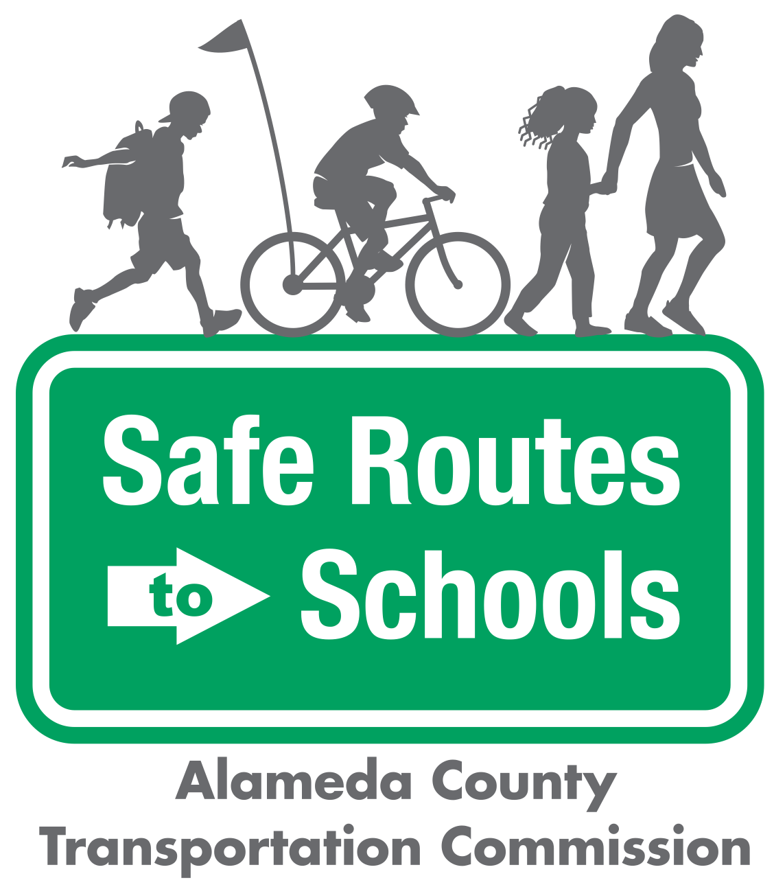

Questions? ¿Preguntas? Contact/Contacto:

info@alamedacountysr2s.org

Bike Train

at ________ Elementary

|  |  |
| --- | --- |
| A Bike Train is a group of students biking to and/or from school with trusted adults. A Bike Train improves children’s safety by biking in a supervised group and it saves parents time and money by sharing the responsibility of taking kids to school.  We have two tentative routes planned for the Bike Train - the yellow route and the blue route (see the map on the back). We anticipate that the Bike Train will happen once a month, starting in ___________________________.  Are you interested in leading a Bike Train route, volunteering, or having your child participate? Fill out the form below!  Questions? Please email [info@alamedacountysr2s.org](mailto:info@alamedacountysr2s.org) |  |

|  |  |  |  |
| --- | --- | --- | --- |
|  | Image result for metropolitan transportation commission, logo no background | |  | | --- | | The Alameda County Safe Routes to Schools Program is a program of the Alameda County Transportation Commission (alamedactc.org) and is funded with Alameda County’s local Measure BB sales tax, and regional, state, and federal funds. | |

---------------------------------------------------------------------------------------------------

PLEASE fill out and return this form to the Main Office.

1. Are you interested in **volunteering** for the Bike Train? If so, which route?

(see map on back). Yellow Route ____ Blue Route _____ No _____

2. Is your child interested in **participating** in a Bike Train? If so, which route?

(see map on back). Yellow Route ____ Blue Route _____ No _____

Parent or Caregiver Name: ________________________________________________

Student(s) Name(s): _____________________________________________________

Phone Number: _________________________________________________________

Email: _________________________________________________________________

Home Address (or nearby intersection): ______________________________________  
______________________________________________________________________

Tentative Bike Train Routes

