Join other families and students biking to school

Únete a otras familias y estudiantes andando en bicicleta a escuela

Bike Train

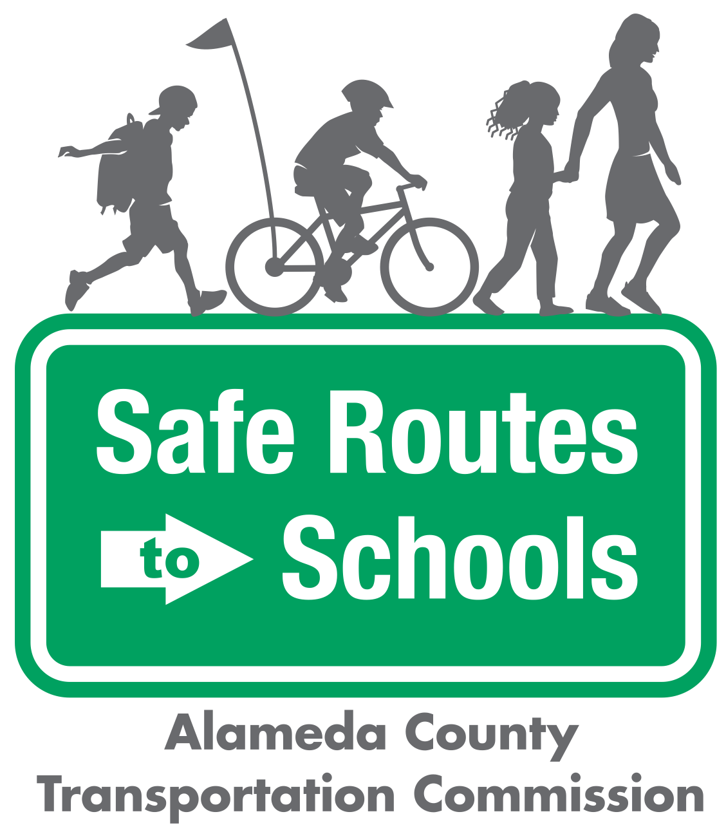

Questions? ¿Preguntas? Contact/Contacto:

info@alamedacountysr2s.org

|  |  |
| --- | --- |
| WHO? Students, route leaders, and volunteers  ¿QUIÉN? Estudiantes y padres que quiren ser líderes  WHAT? A Bike Train is a group of students biking to and from school with friends and trusted adults.  ¿QUÉ? Un Tren de Bicicletas es un grupo de estudiantes que andan en bicicleta a y de escuela con padres que sirven como guías estudiantes  WHEN? Beginning _________ for the ____________ school year.  ¿CUÁNDO? Empezando ________________ para el año escolar ________  WHY? Have fun with friends, exercise, explore outdoor activity, and save the planet!  ¿POR QUÉ? Diviértete con tus amigos, haz ejercicio, explora actividades afuera y salva el planeta |  |

|  |  |  |
| --- | --- | --- |
| Image result for metropolitan transportation commission, logo no background |  | The Alameda County Safe Routes to Schools Program is a program of the Alameda County Transportation Commission (alamedactc.org) and is funded with Alameda County’s local Measure BB sales tax, and regional, state, and federal funds. |

---------------------------------------------------------------------------------------------------

**1. Are you interested in participating as a Bike Train Route Leader or Volunteer?**

¿Esta interesado en participar como guia/lider de un Tren di Bicicletas?

Yes/Sí ____ No _____

**2. Is your child interested in participated in a Bike Train?**

¿Crees que su hijo/hija esta interesado en participar en un Tren de Bicicletas?

Yes/Sí ____ No _____

Parent Name/Nombre del Padre o Madre: ___________________________________________

Phone Number/Número de teléfono: _______________________________________________