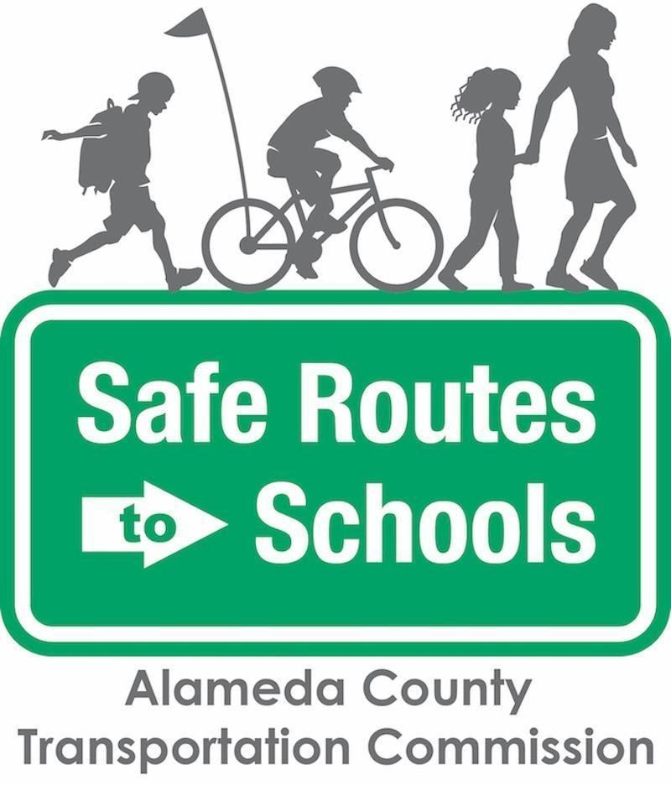

Newsletter/Parent Letter Text – English
Bike to School Day
Safe Routes to Schools – Bike to School Day
Lace up those shoes and dust off those wheels: Bike to School Day is BACK on Thursday, May 16, 2024!
This annual event is a great opportunity for families and students to try bicycling or rolling to school for the first time or to renew a commitment to healthy and safe travel to school.
Remember, this event is not just for bikes! All active modes — including scooters, skateboards, roller skates, and walking — are encouraged. Registered schools receive free resources to help encourage and celebrate safe and active travel.
Bike to School Day is an event organized by Alameda County’s Safe Routes to Schools (SR2S) Program, which is sponsored by the Alameda County Transportation Commission. For more information about the Alameda County Safe Routes to Schools Program, visit our website.
If you have questions or want to get involved, contact [insert name] at [insert phone number and/or email].
Have fun!

