Alameda County Safe Routes to Schools

Golden Sneaker Contest Social Media Toolkit

Social media is a great way to reach students, teachers, and the broader community quickly and frequently. That’s why we’ve put together this social media toolkit to provide text and graphics for our Alameda County Safe Routes to Schools (SR2S) partners to share their excitement for the Golden Sneaker Contest on their organizations’ social media accounts. This toolkit was created for:
- School administrators
- School districts
- Elected officials
- Parents and caregivers
- You!

You can choose which social media post to use based on the Safe Routes to Schools theme you want to communicate to your community. Go with what works best for you! As a reminder, here are the SR2S themes:
- Building community
- Encouraging students to be physically active
- Reducing emissions and climate change
- Reducing traffic congestion
- Promoting choices to use active and shared transportation
- Increasing safety on our streets
- Improving academic performance

How to Use these Social Media Posts
Heads up!
Some text is highlighted yellow for you to personalize. Remember to change it before posting online!
We’ve put together instructions and posts that you can use to promote the contest. When you want to use one, just do the following:
- Download images from this toolkit and save them to your device.
- Log on to your social media site, such as Facebook, X, formerly known as Twitter, or Instagram.
- Use text we’ve provided or create your own message into a post or series of posts and include the #GoldenSneakerContest hashtag.
- Upload the image you saved to your device to accompany your text.
- Post away!

Post 1
Theme: Build community on campus and in classrooms | When to post: Anytime now until Friday, February 2
Who should post this?: Elected officials, school administrative staff of participating schools | Post content: Looking for a way to build community at your school? Join the #GoldenSneakerContest! Classrooms work together to walk, bike, roll, use shared transit, and carpool to school to win the coveted Golden Sneaker trophy in this @AlamedaCoSR2S event. Join in the fun! 👟🥾👢

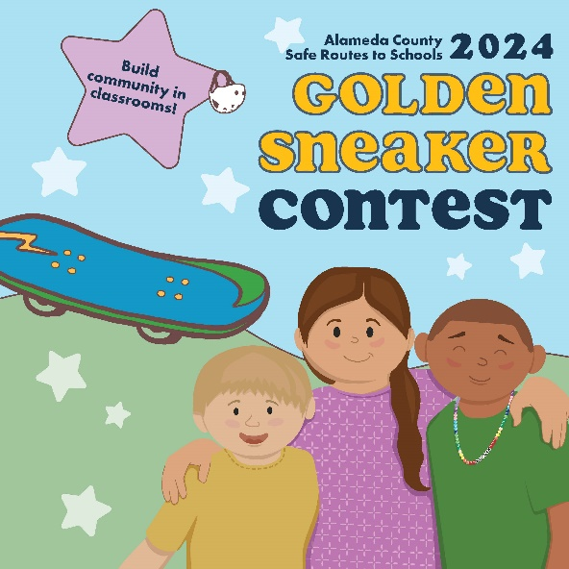  Facebook graphic | 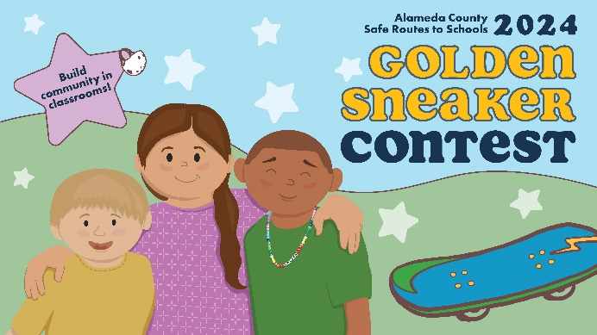  X, formerly known as Twitter graphic | Instagram graphic  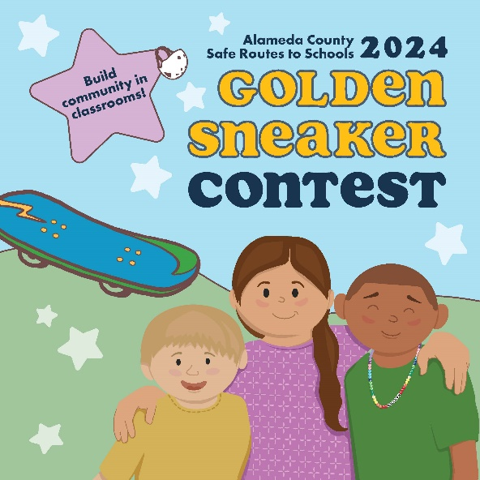

Post 2
Theme: Build community on campus and in classrooms | When to post: Anytime now until Friday, February 2
Who should post this: Elected officials | Post content: I’m overjoyed to support community-building in the #GoldenSneakerContest, where classrooms work together to walk, bike, roll, take transit, or carpool to win the Golden Sneaker trophy. Show your support for this @AlamedaCoSR2S event! Register here: http://tinyurl.com/yn3s9f8x

Facebook graphic  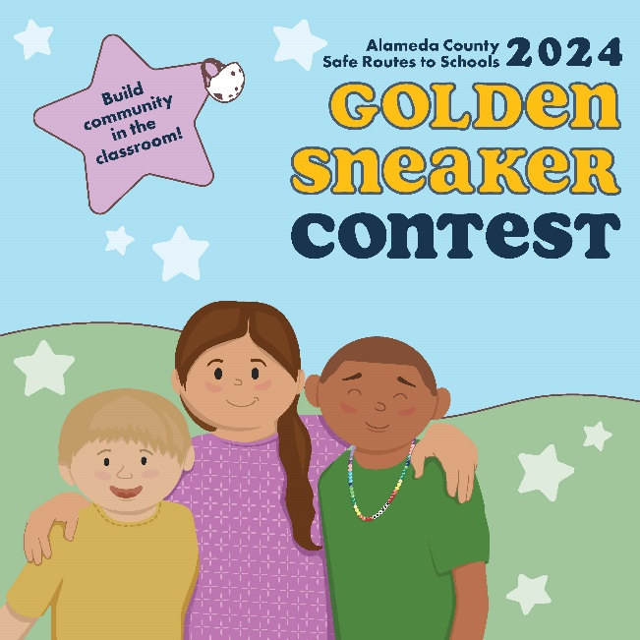 | X, formerly known as Twitter  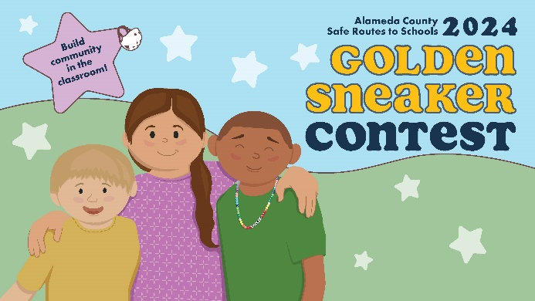 | Instagram graphic  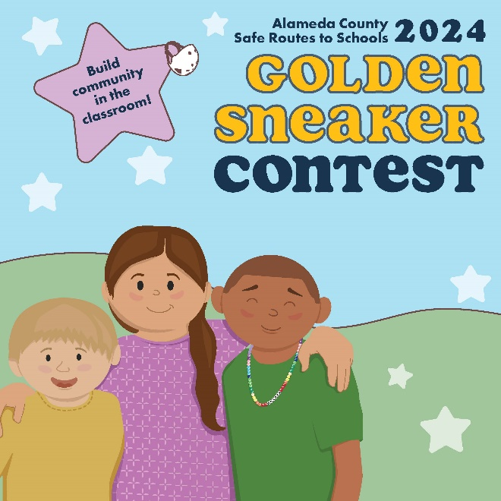

Post 3
Theme: Encourage students to be physically active | When to post: Between Monday, March 4 and Friday, March 15.
Who should post this: Anyone! | Post content: Did you know walking can help children achieve the CDC’s recommended amount of 60 minutes of daily exercise? The #GoldenSneakerContest is a great way to get that physical activity in! 🏃 Let’s get moving and join this @AlamedaCoSR2S event!

Facebook graphic  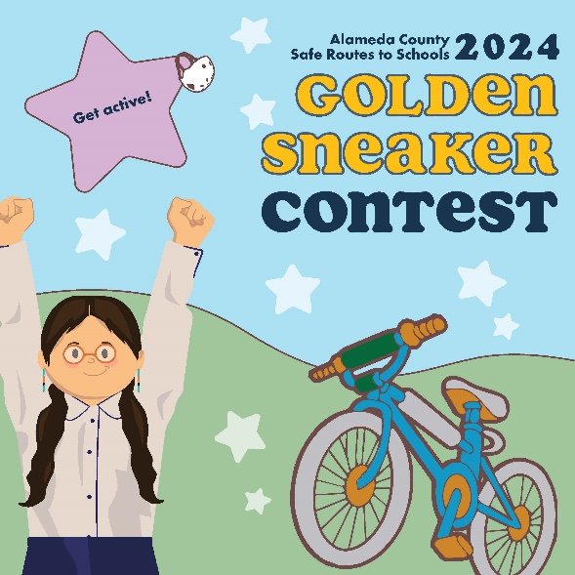 | X, formerly known as Twitter  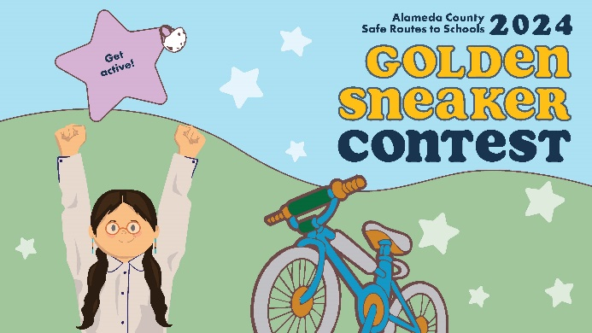 | Instagram graphic  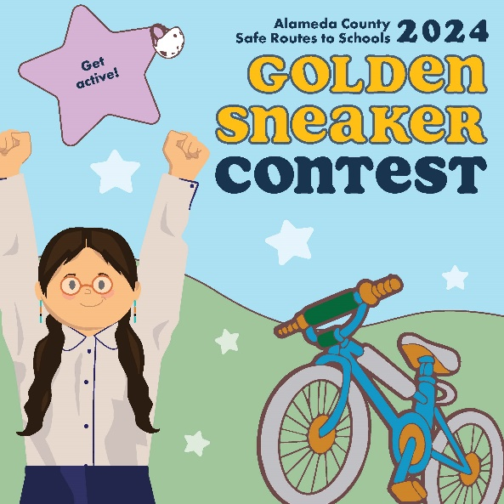

Post 4
Theme: Reduce pollution | When to post: Between Monday, March 4 and Friday, March 15.
Who should post this: Anyone! | Post content: I’m [walking, rolling, using public transit, or carpooling] for the @AlamedaCoSR2S #GoldenSneakerContest because it keeps us healthy by reducing air pollution around my school - and it’s fun! Join the contest, March 4 - March 15.

Facebook graphic  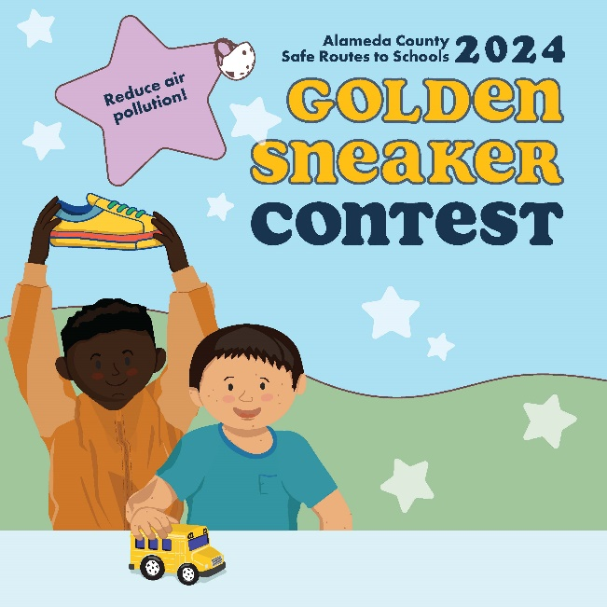 | X, formerly known as Twitter  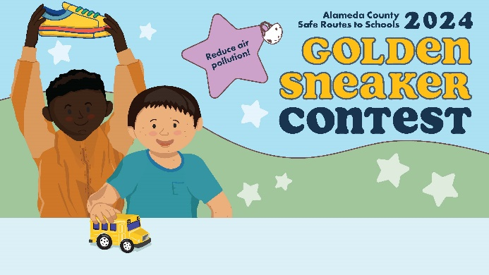 | Instagram graphic  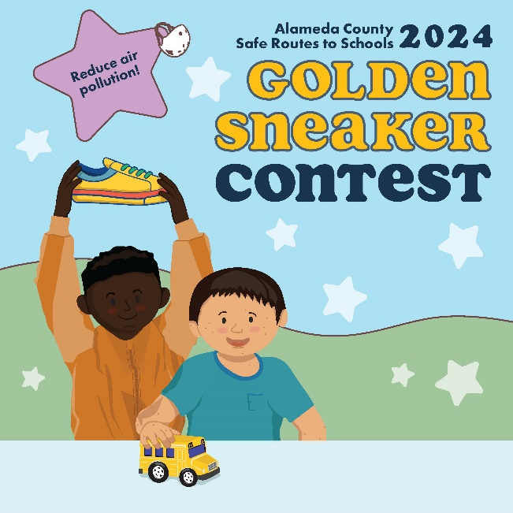

Post 5
Theme: Reduce pollution | When to post: Anytime now until Friday, March 15.
Who should post this: Elected officials | Post content: Reducing vehicle emissions is critical to keeping our air and planet clean! That’s why you and your school community should participate in @AlamedaCoSR2S’s #GoldenSneakerContest, Mar 4 - Mar 15. Together, we can keep ourselves and our planet healthy 💪 🌎

Facebook graphic  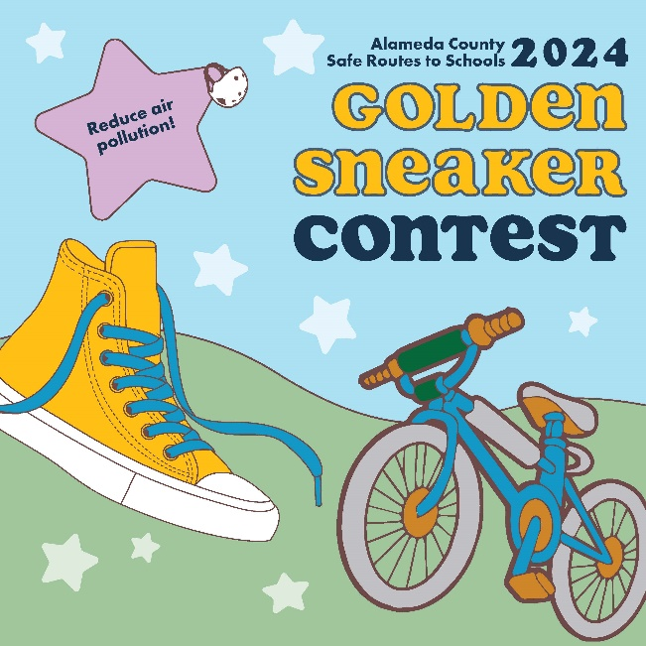 | X, formerly known as Twitter  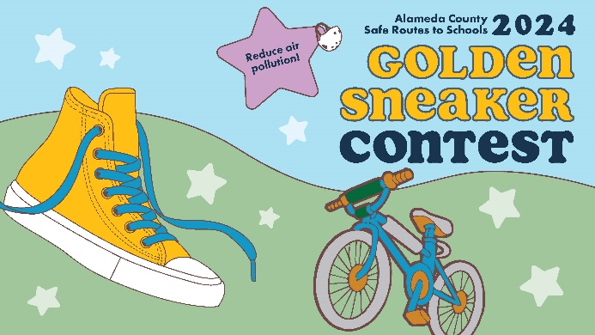 | Instagram graphic  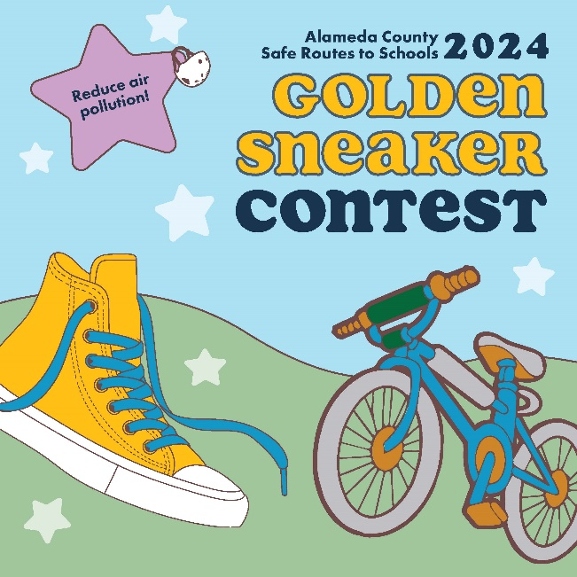

Post 6
Theme: Reduce traffic congestion | When to post: Anytime now until Friday, March 15.
Who should post this: Anyone! | Post content: Join the many schools in Alameda County that are choosing not to wait in drop-off traffic and instead are walking, rolling, or using shared transit to school during the #GoldenSneakerContest, Mar 4 - Mar 15. @AlamedaCoSR2S

Facebook graphic  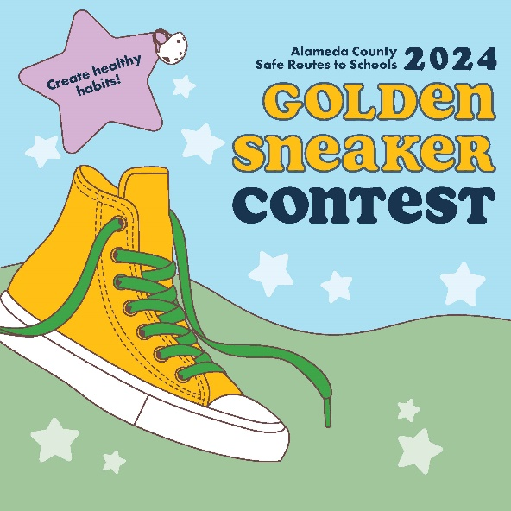 | X, formerly known as Twitter  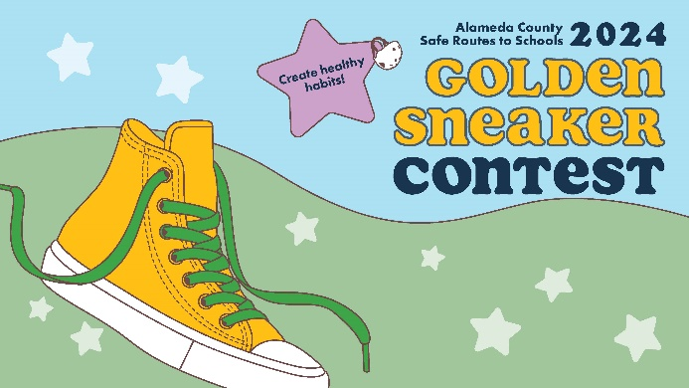 | Instagram graphic  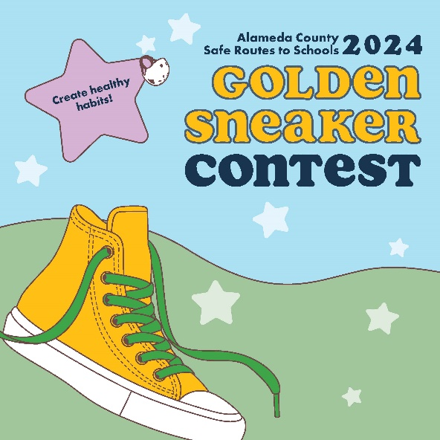

Post 7
Theme: Promote the choice to use active and shared transportation | When to post: Anytime now until Monday, March 4.
Who should post this: Anyone! | Post content: Jumpstart a new healthy habit with the #GoldenSneakerContest!! Join your school community (Mar 4 – Mar 15) and walk, bike, roll, carpool, or take shared transit to school to compete! The benefits are endless! @AlamedaCoSR2S

Facebook graphic  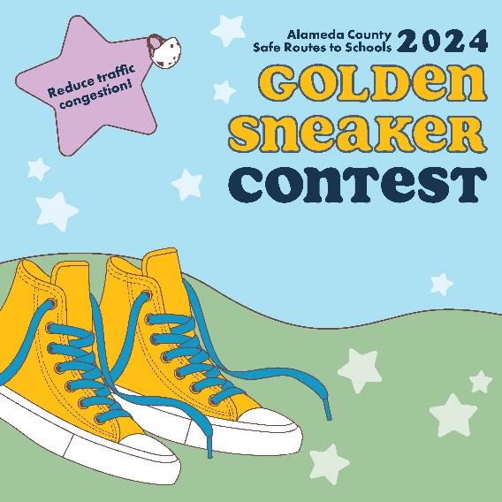 | X, formerly known as Twitter  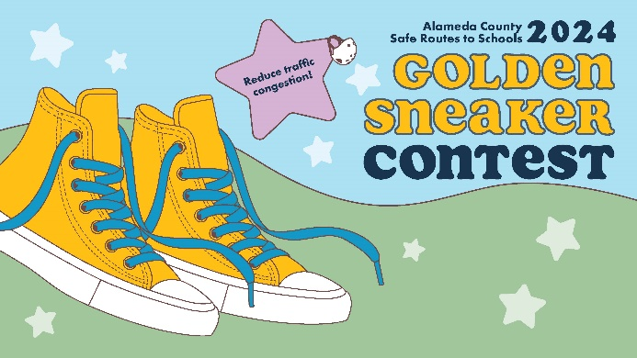 | Instagram graphic  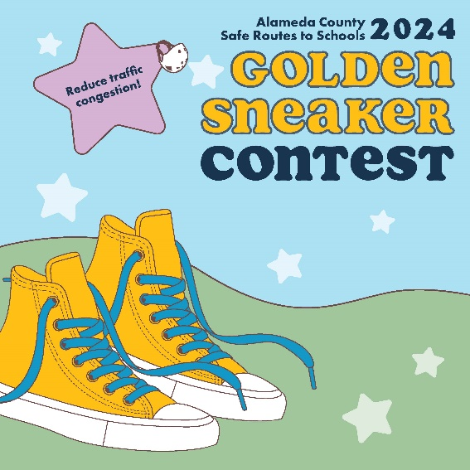

Post 8
Theme: Increasing safety on our streets | When to post: Anytime now until Friday, March 15.
Who should post this: Anyone! | Post content: I’m [walking, rolling, using shared transit, or carpooling] for the @AlamedaCoSR2S #GoldenSneakerContest because fewer cars = fewer crashes and make our school streets safer. Join the fun March 4 - March 15!

Facebook graphic  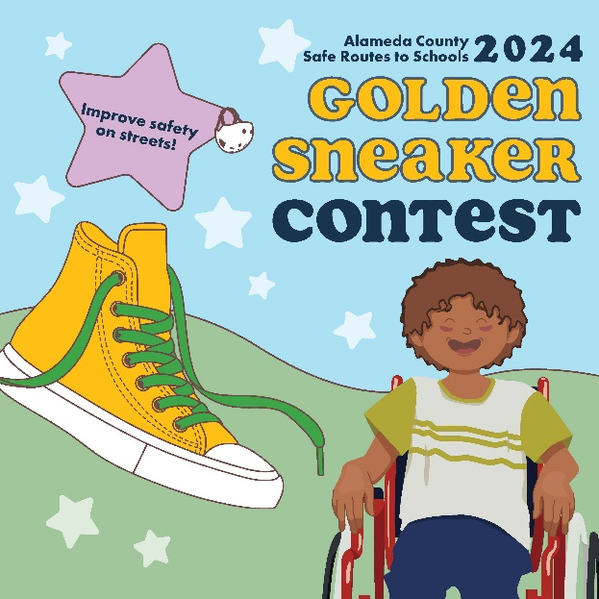 | X, formerly known as Twitter  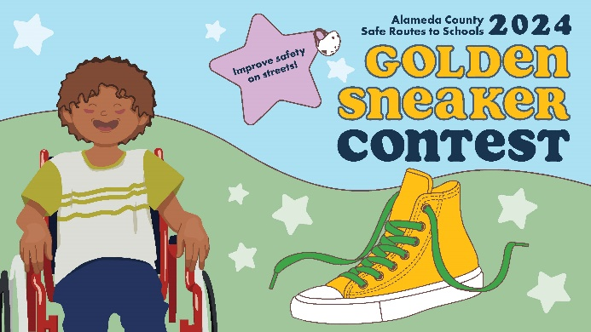 | Instagram graphic  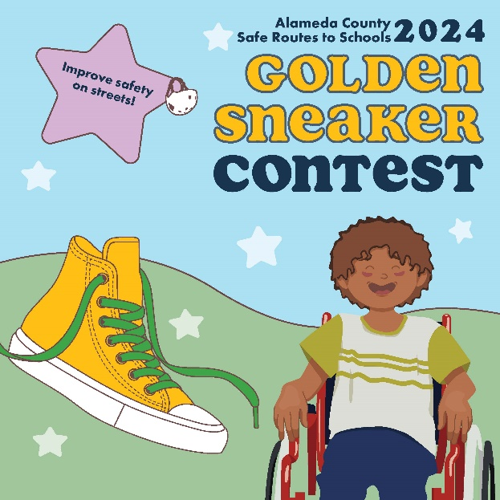

Post 9
Theme: Improving academic performance | When to post: Anytime between Monday, March 4 and Friday, March 15.
Who should post this: Families and caregivers | Post content: My family is [walking, rolling, using shared transit, or carpooling] for the @AlamedaCoSR2S #GoldenSneakerContest because physical activity before school boosts academic performance and supports mental health. Join the contest now until March 15!

Facebook graphic  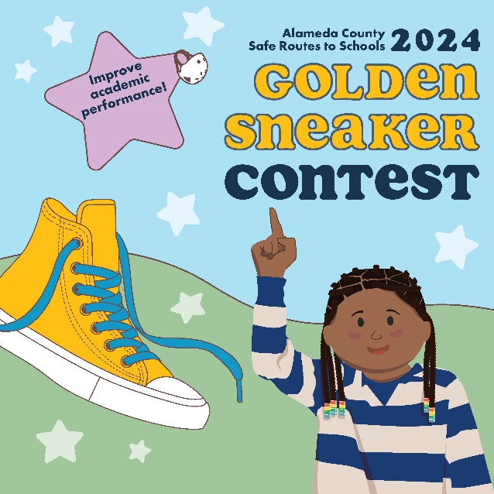 | X, formerly known as Twitter  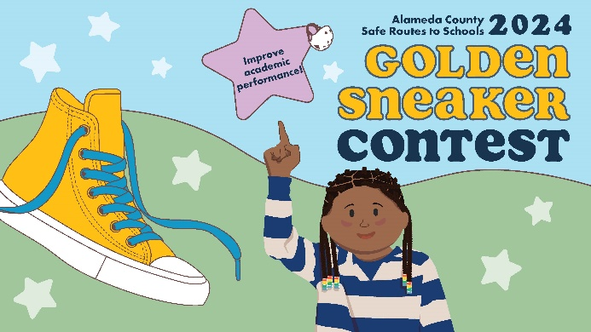 | Instagram graphic  