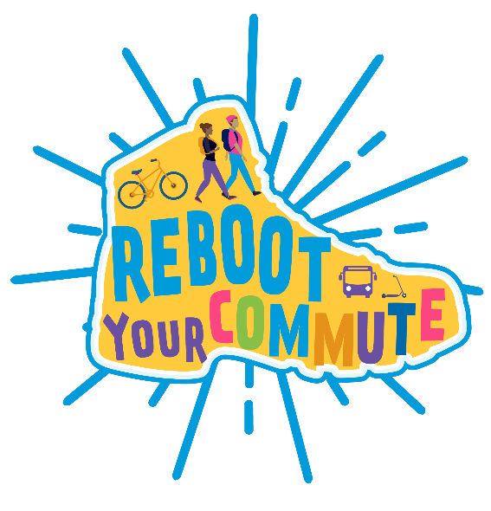

Social Media Posts
Use the logo as the graphic for any social media post, or create your own!

1 week before:

Facebook or Instagram
[High school name] students are ready to walk, roll, carpool, and take transit— and they’re also ready to tell you why. Join us [time, e.g., before school, at lunch, etc.] at [location, e.g., in front of the school, cafeteria, etc.] on [date] for Reboot Your Commute, an @AlamedaCoSR2S event! We want to know why you walk, bike, roll, take transit, or carpool to school. Join the fun and earn a chance to win a $50 Clipper Card! #saferoutestoschools

Twitter
[High school name] students are ready to walk, roll, carpool, and take transit—and they’re also ready to tell you why during our Reboot Your Commute event on [date] at [location]. Learn more at @ AlamedaCoSR2S! #saferoutestoschools
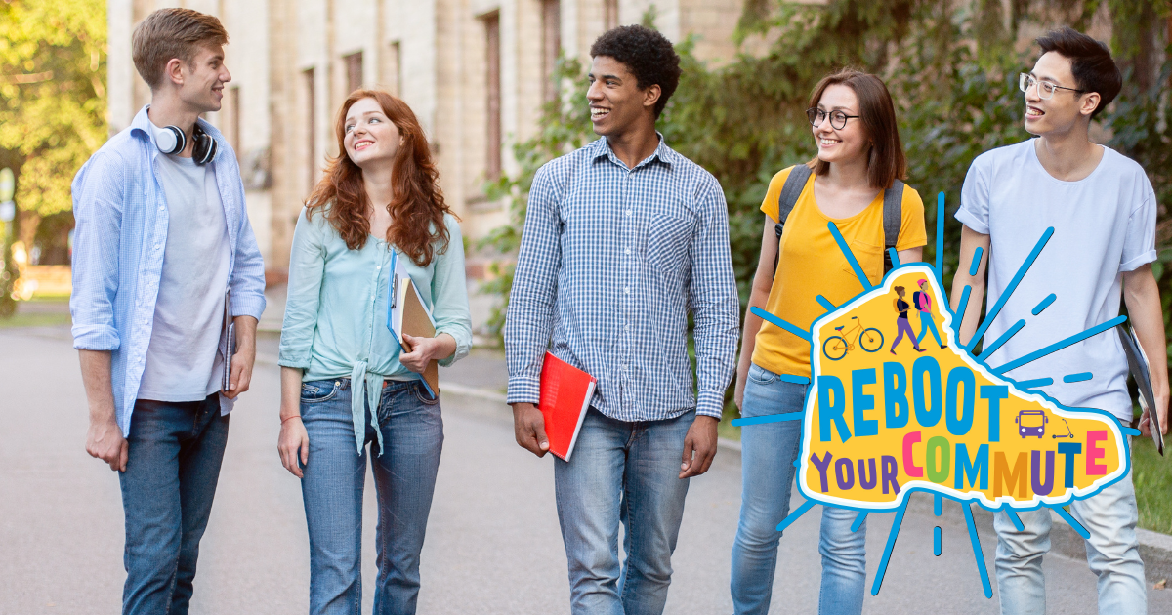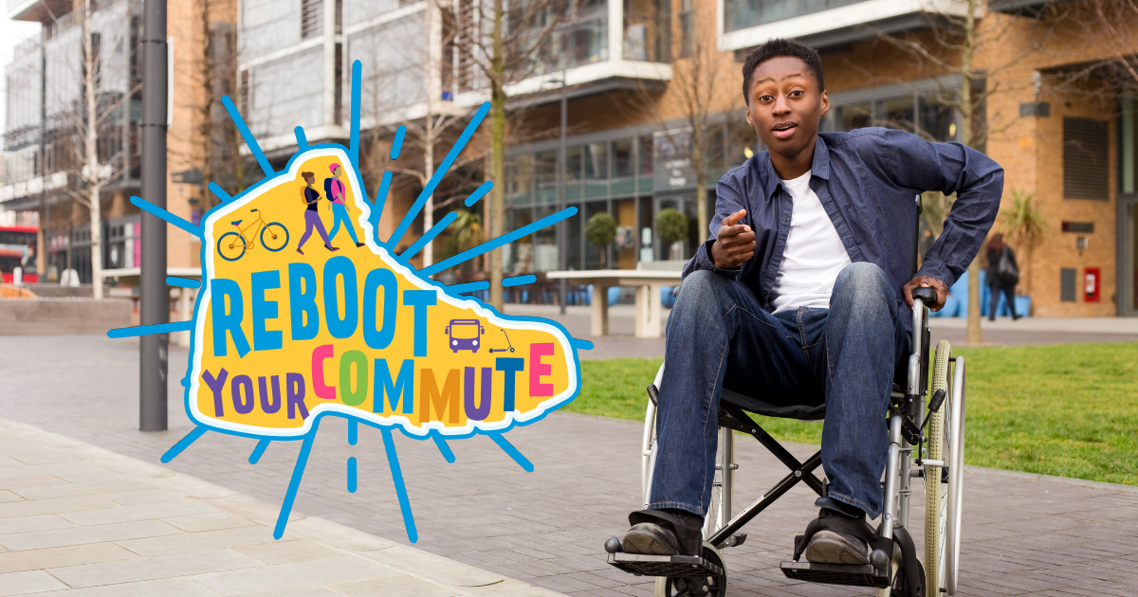

Day before the event:

Facebook or Instagram
Reboot Your Commute is tomorrow!! Lace up your shoes, pump up those bike tires, find that Clipper Card, or text a friend to carpool. It's on.
Join us [time, e.g., before school, at lunch, etc.] at [location, e.g., in front of the school, cafeteria, etc.] on [date] for Reboot Your Commute, an @AlamedaCoSR2S event! We want to know why you walk, bike, roll, take transit, or carpool to school. Join the fun and earn a chance to win a $50 Clipper Card! #saferoutestoschools

Twitter
Reboot Your Commute is tomorrow!! Lace up your shoes, pump up those bike tires, find that Clipper Card, or text a friend to carpool. See you tomorrow during our Reboot Your Commute event on [date] at [location]. Learn more at @ AlamedaCoSR2S! #saferoutestoschools
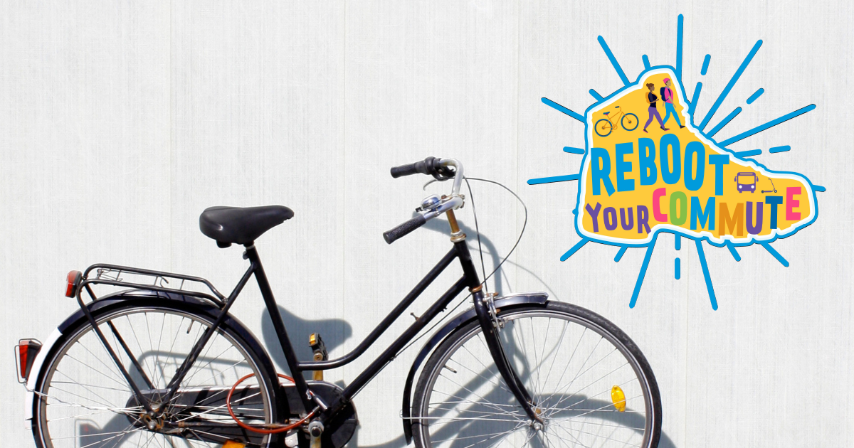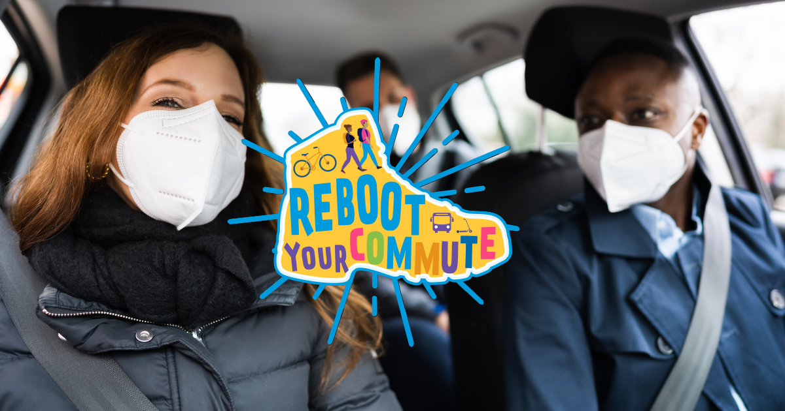

Morning of event:

Facebook or Instagram
Good morning, [school mascot]! Are you ready to Reboot Your Commute? It's today!
Join us [time, e.g., before school, at lunch, etc.] at [location, e.g., in front of the school, cafeteria, etc.] on [date] for Reboot Your Commute, an @AlamedaCoSR2S event! We want to know why you walk, bike, roll, take transit, or carpool to school. Join the fun and earn a chance to win a $50 Clipper Card! #saferoutestoschools

Twitter/X
It's today! Head to school on foot, bike, transit, or in a carpool and stop by [school name]'s Reboot Your Commute event table. We'll be at [location] [time, e.g. before school, at lunch, etc.]. Learn more at @ AlamedaCoSR2S! #saferoutestoschools
