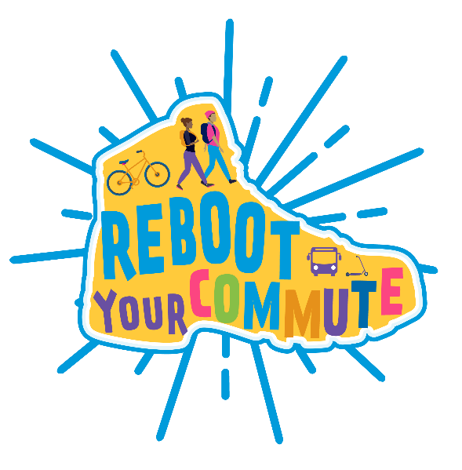

Newsletter Template
Fill in the red text for your school and event!

Template Text (English):
Celebrate Reboot Your Commute on [Day of Event]!

Join [name of school] for Reboot Your Commute and celebrate using active and shared transportation like walking, biking, rolling, taking transit and carpooling! We will have a table set up at [time] in [location] with an area where you can write or draw about the reasons why you use active and shared transportation. Help us fight climate change, stay physically healthy and reduce traffic alongside the Alameda County Safe Routes to Schools program. All Reboot Your Commute participants will be entered into a drawing to win a $50 Clipper Card!
You can participate by:
- Walking, or riding a bike, skateboard or scooter
- Using the bus and walking to and from the bus stop
- Carpooling with friends
- Walking the last few blocks to school after being dropped off

Post a fun photo on social media to celebrate the day! Remember to tag @AlamedaCoSR2S on Twitter/X with #RebootYourCommute, and post on Facebook at facebook.com/saferoutestoschool.
We look forward to celebrating Reboot Your Commute with you!

