Alameda County Safe Routes to Schools

Bike to School Day Social Media Toolkit

Social media is a great way to reach students, teachers, and the broader community quickly and frequently. That’s why we’ve put together this social media toolkit to provide text and graphics for our Alameda County Safe Routes to Schools (SR2S) partners to share their excitement for Bike to School Day on their organizations’ social media accounts. This toolkit was created for:
- School administrators
- School districts
- Elected officials
- Parents and caregivers
- You!

You can choose which social media post to use based on the Safe Routes to Schools theme you want to communicate to your community. Go with what works best for you! As a reminder, here are the SR2S themes:
- Building community on campus and in classrooms
- Encouraging students to be physically active
- Reducing pollution
- Reducing traffic congestion
- Promoting the choice to use active and shared transportation
- Increasing safety on our streets
- Improving academic performance

How to Use these Social Media Posts
Heads up!
Some text is highlighted yellow for you to personalize. Remember to change it before posting online!
We’ve put together instructions and posts that you can use to promote the event. When you want to use one, just do the following:
- Download images from this toolkit and save them to your desktop.
- Log on to your social media site, such as Facebook, Twitter or Instagram.
- Copy and paste the text we’ve provided into your post, or create your own message that includes the #BikeToSchoolDay hashtag.
- Upload the image you saved to your desktop to accompany your text.
- Post away!

Post 1
Theme: Build community on campus and in classrooms | When to post: Anytime now until Thursday, May 11th
Who should post this?: Elected officials, school administrative staff of participating schools | Post content: Looking for a way to build community at your school? Join #BikeToSchoolDay! Celebrate active transportation by biking, walking, or rolling to school during this @AlamedaCoSR2S event. Join in the fun! 👟🥾👢

Facebook graphic  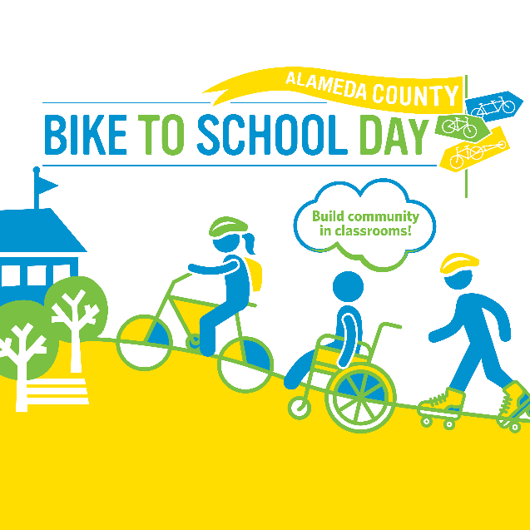 | Twitter graphic  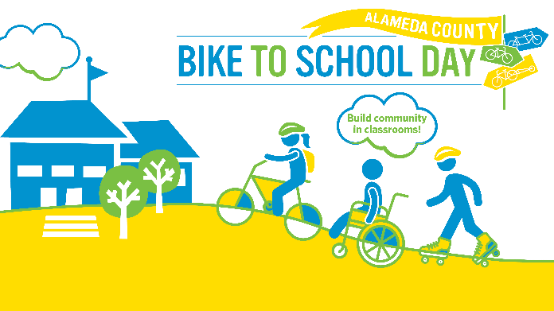 | Instagram graphic  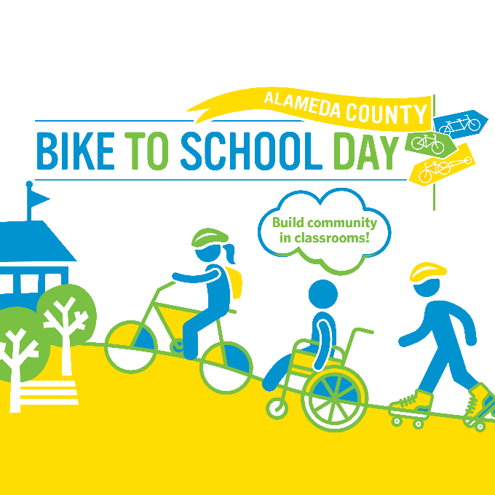

Post 2
Theme: Build community on campus and in classrooms | When to post: Anytime now until Thursday, May 11th
Who should post this?: Elected officials | Post content: I’m overjoyed to support community-building on #BikeToSchoolDay, which encourages students and families to walk, bike, or roll to school. Show your support for this @AlamedaCoSR2S event! Register here: https://airtable.com/shr2FeEBDnoQd4tLu

Facebook graphic  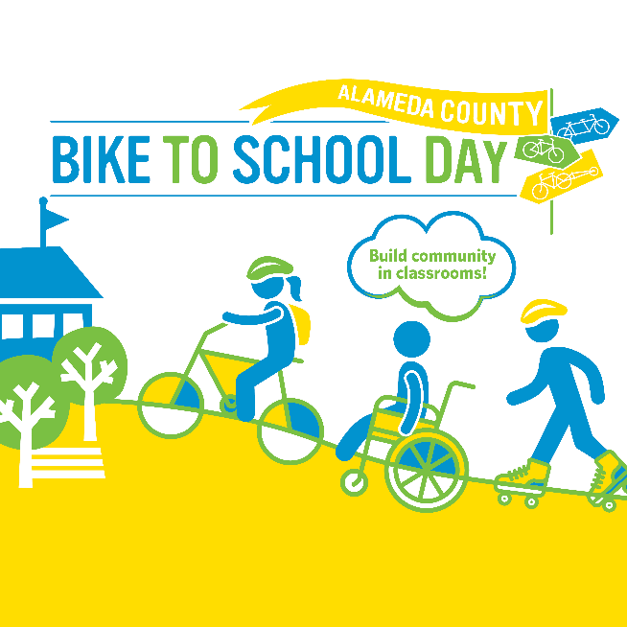 | Twitter graphic  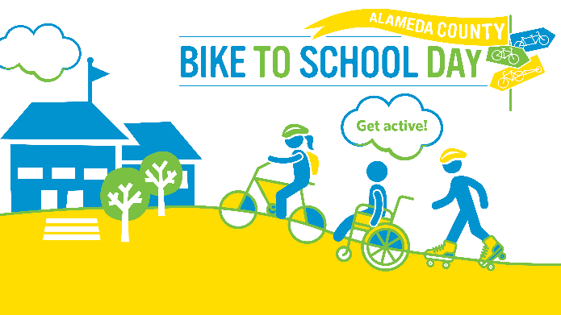 | Instagram graphic

Post 3
Theme: Encourage students to be physically active | When to post: Anytime now until Thursday, May 11th
Who should post this?: Anyone! | Post content: Did you know biking to school can help children achieve the CDC’s recommended amount of exercise? Biking, walking, or rolling on #BikeToSchoolDay is a great way to get moving! 🏃 Let’s all get moving and join this @AlamedaCoSR2S event!

Facebook graphic  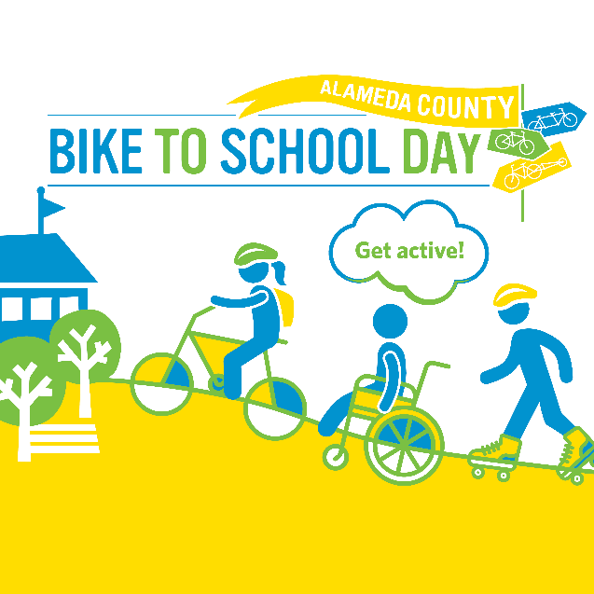 | Twitter graphic  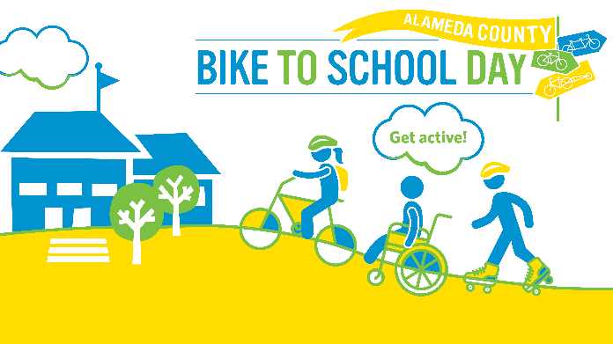 | Instagram graphic  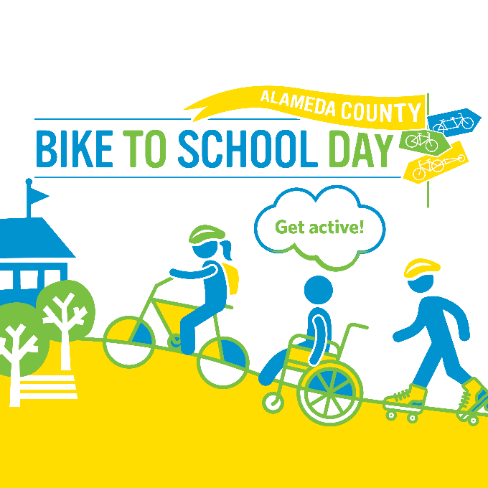

Post 4
Theme: Reduce pollution | When to post: Anytime now until Thursday, May 11th
Who should post this?: Anyone! | Post content: I’m [select: walking, biking, rolling] for the @AlamedaCoSR2S #BikeToSchoolDay because it keeps us healthy by reducing air pollution around my school - and it’s fun!

Facebook graphic  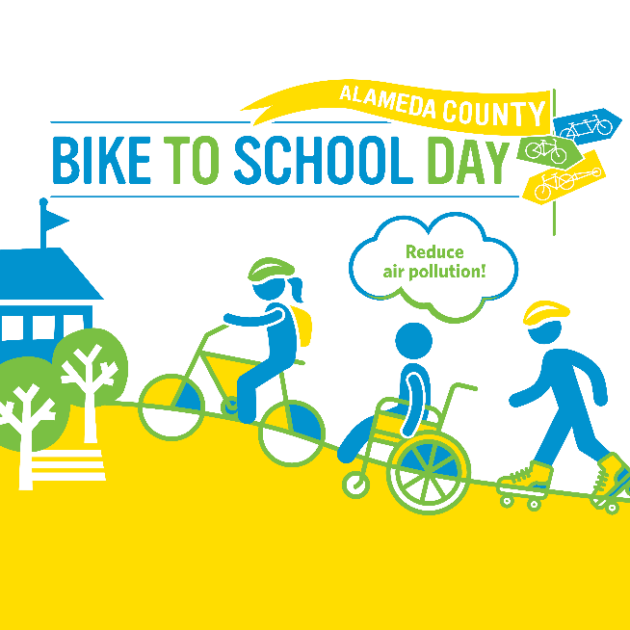 | Twitter graphic  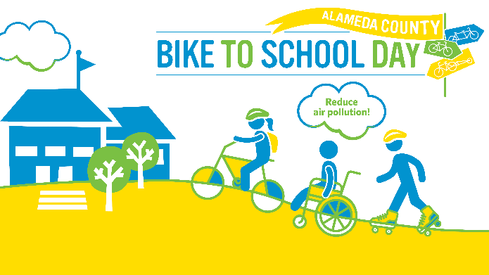 | Instagram graphic  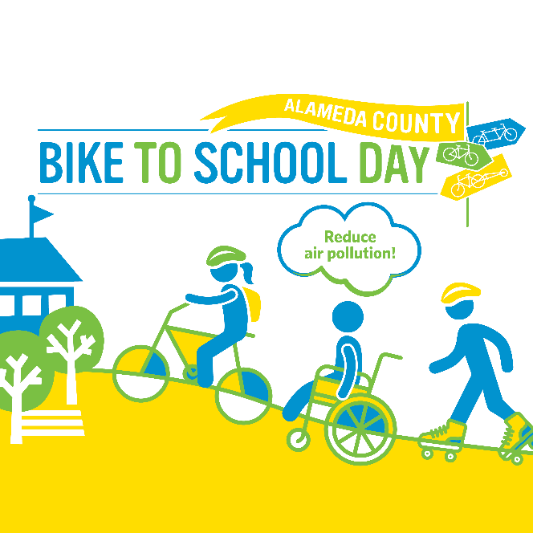

Post 5
Theme: Reduce pollution | When to post: Anytime now until Thursday, May 11th
Who should post this?: Elected officials | Post content: Reducing vehicle emissions is critical to keeping our air and planet clean. That’s why you and your school community should participate in @AlamedaCoSR2S’s #BikeToSchoolDay, May 11. Together, we can keep ourselves and our planet healthy 💪 🌎

Facebook graphic  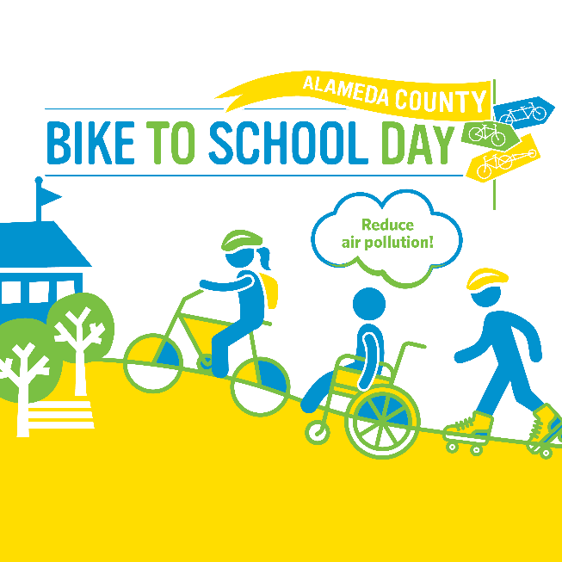 | Twitter graphic | Instagram graphic

Post 6
Theme: Reduce traffic congestion | When to post: Anytime now until Thursday, May 11th
Who should post this?: Anyone! | Post content: Join the many schools in [insert jurisdiction name] that are choosing not to wait in drop-off traffic and instead are walking, biking, and rolling to school on #BikeToSchoolDay, May 11. @AlamedaCoSR2S

Facebook graphic  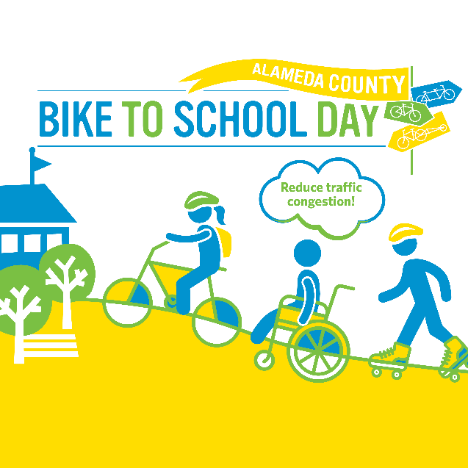 | Twitter graphic  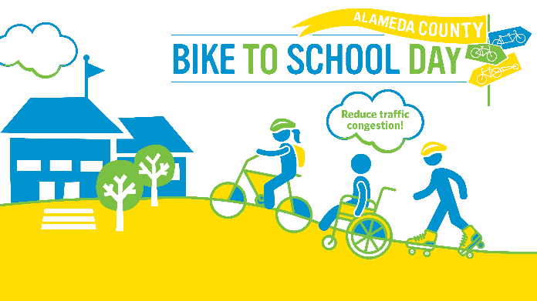 | Instagram graphic  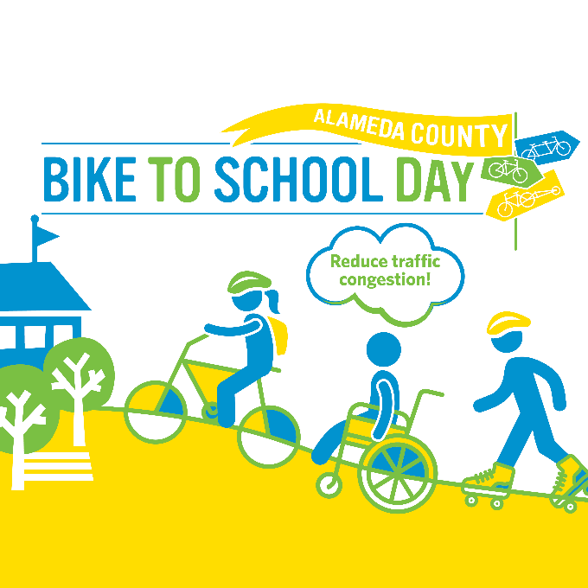

Post 7
Theme: Promote the choice to use active and shared transportation | When to post: Anytime now until Thursday, May 11th
Who should post this?: Anyone! | Post content: Jumpstart a new healthy habit with #BikeToSchoolDay! Join your school community to walk, bike, roll, carpool, or take shared transit on May 11th! The benefits are endless! @AlamedaCoSR2S

Facebook graphic  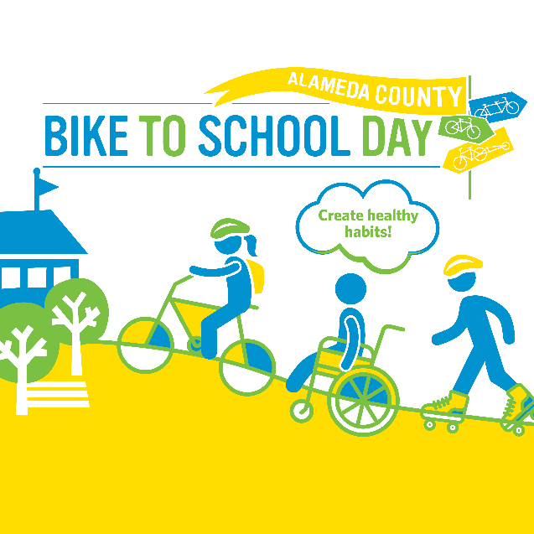 | Twitter graphic  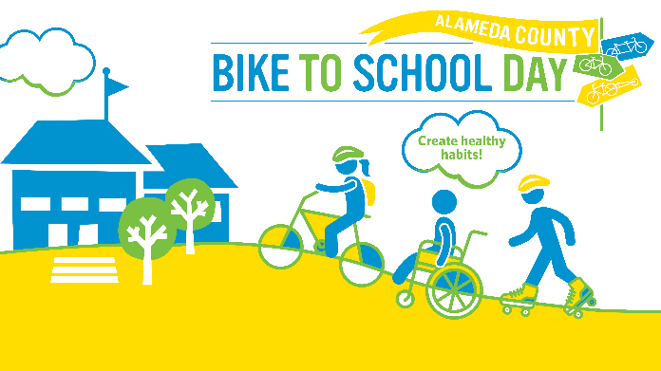 | Instagram graphic  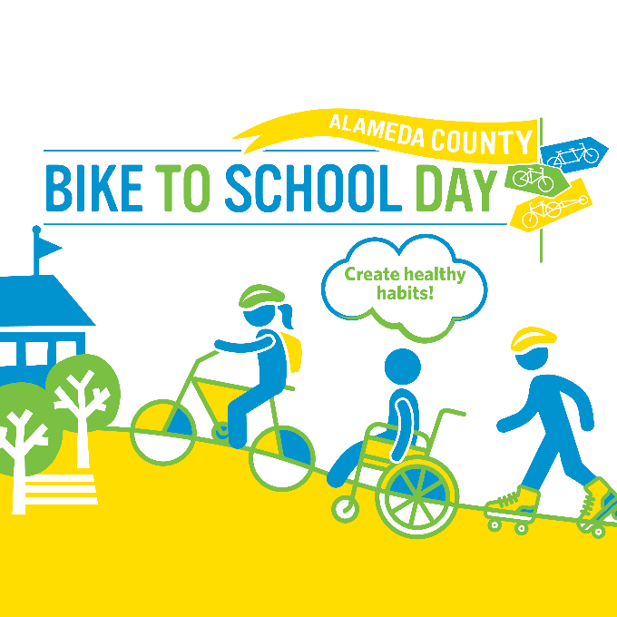
Post 8
Theme: Increasing safety on our streets | When to post: Anytime now until Thursday, May 11th
Who should post this?: Anyone! | Post content: I’m [select: walking, biking, rolling] for the @AlamedaCoSR2S #BikeToSchoolDay because fewer cars = fewer crashes and make our school streets safer. Join the fun May 11.

Facebook graphic  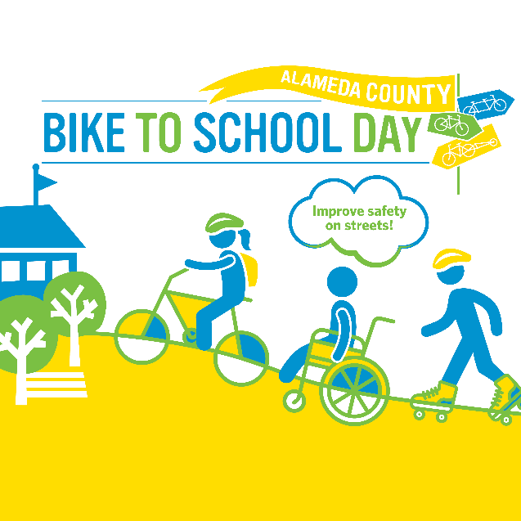 | Twitter graphic  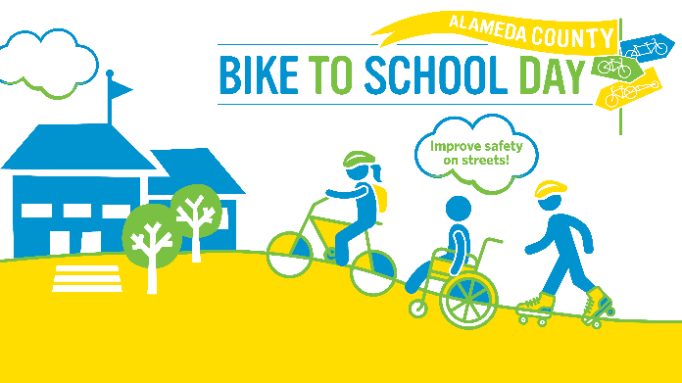 | Instagram graphic  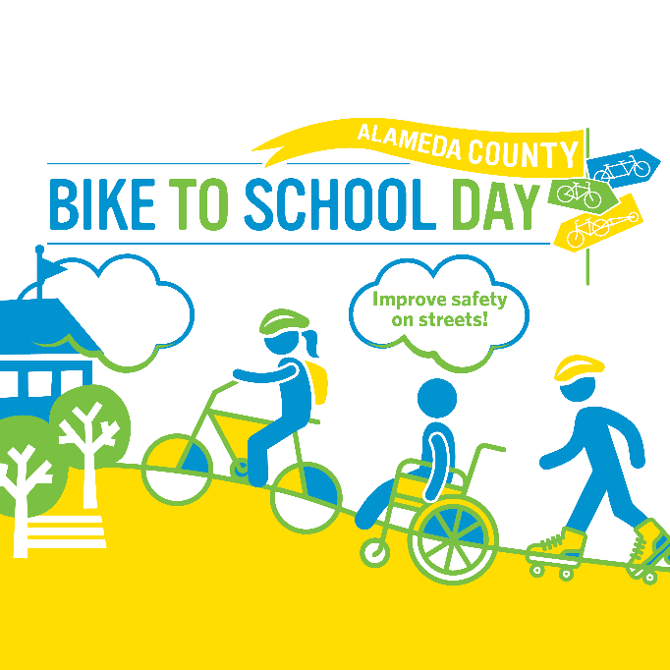

Post 9
Theme: Improving academic performance | When to post: Anytime now until Thursday, May 11th
Who should post this?: Families and caregivers | Post content: My family is [select: walking, biking, rolling] for the @AlamedaCoSR2S #BikeToSchoolDay because physical activity before school boosts academic performance and supports mental health!

Facebook graphic  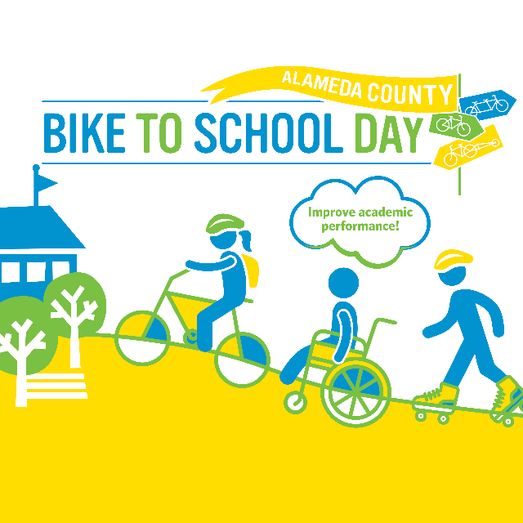 | Twitter graphic  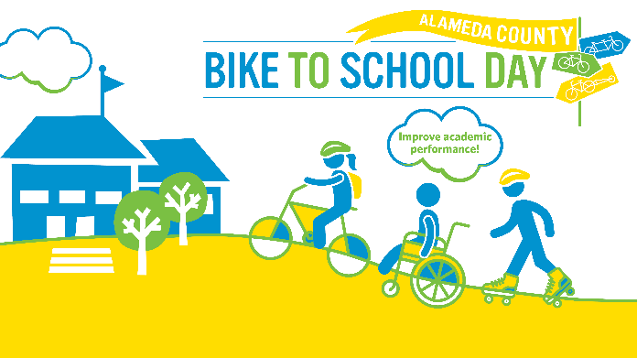 | Instagram graphic  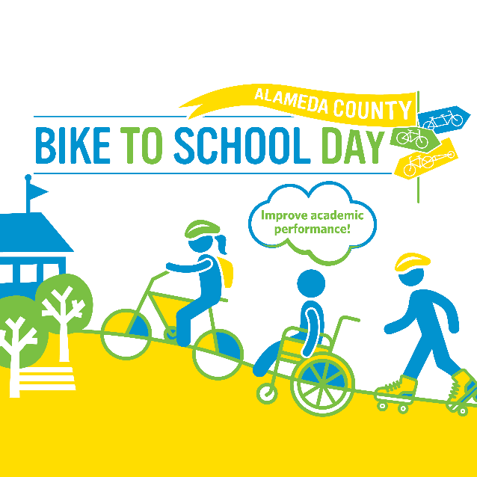

Post 10
Theme: Encourage peers to use active transportation | When to post: Anytime now until Thursday, May 11th
Who should post this?: High school students | Post content: I’m [select: walking, biking, rolling] to school for the @AlamedaCoSR2S #BikeToSchoolDay to keep myself and the planet healthy. See you out there, [tag friends].

Facebook graphic | Twitter graphic | Instagram graphic

