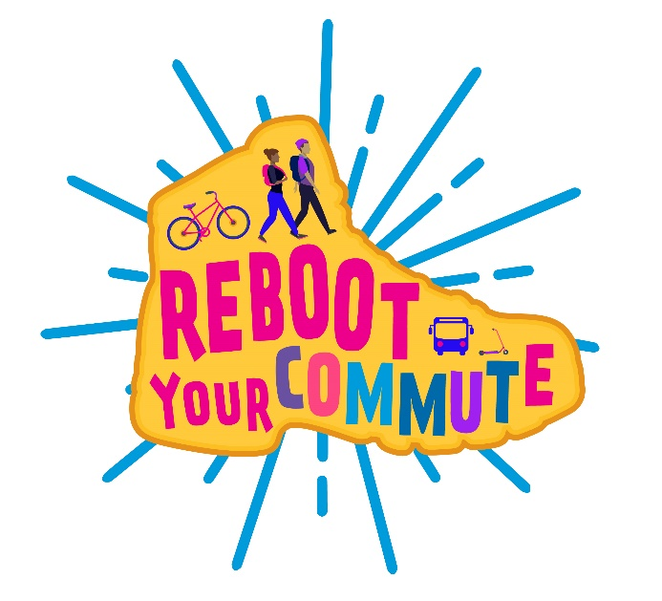

Email Template

On [date], students will be hosting [high school name]'s Reboot Your Commute Event! Join us for this Alameda County Safe Routes to Schools event at [location] between [times] to celebrate and share the reasons why we use active and shared transportation like walking, biking, rolling, taking transit, and carpooling.
Any student that uses active or shared transportation to get to school on [date] will receive one ticket that will be entered into a drawing to win a $50 Clipper Card. Students can earn an additional ticket by writing or drawing why they used active or shared transportation on a community board at the event.
We look forward to celebrating Reboot Your Commute with you!

