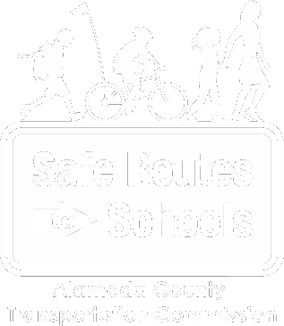
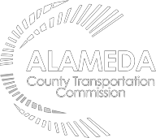
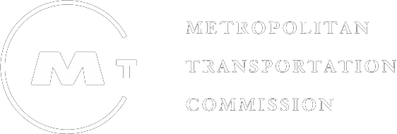

Ongoing Walk and Roll
NOVEMBER
Learn more at alamedacountysr2s.org

The Alameda County Safe Routes to Schools Program is a program of the Alameda County Transportation Commission (alamedactc.org) and is funded with Alameda County’s local sales tax Measure B, regional, state and federal funds.

Theme: November’s focus is INCLUSION! Inclusion is important because creating spaces where everyone is welcome makes us all feel comfortable and welcome. This month we honor inclusion and social justice champions like Ruby Bridges who opened up the door for racial inclusion in schools. We encourage students to practice an inclusive mindset on their walk and roll to school.

Activities you might want to do before your walk and roll event:
- Watch this video (K-2; 3-5)to learn more about Ruby Bridges. Discuss how the video made you feel and what you might talk about on your walk to school.
- Check out this website to learn more about Ruby Bridges. How did she work toward an inclusive community, and what examples could you follow?
Activities you might want to do after your walk and roll event:
- While on your walk or roll, talk about three things you can do to make other people feel included.

Make sure to use these helpful tips on your walk!

.

