Social media post templates
To use as a general post:
On Oct 6, celebrate International Walk and Roll to School Day! Make your community safer and healthier by walking, biking, scooting, skating, or taking public transportation during this fun @AlamedaCoSR2S event. #walkandroll21
To use if you are attending the event:
Please join me in celebrating International Walk and Roll to School Day on Oct 6! I’m excited to participate in this fun @AlamedaCoSR2S event. #walkandroll21
Email template
Dear [Constituents/Members of the Community/ Members of the Public/other recipients],
The health of our community is vital. Therefore, I want to raise awareness of International Walk and Roll to School Day on October 6, an event happening across Alameda County (and the world!) that celebrates walking, biking, taking transit, and using other environmentally friendly modes to travel. Regardless of whether your child is in school or learning virtually, I invite you and your family to get outside to walk and roll safely. Your participation will build community, encourage healthy habits, and reduce traffic congestion on our streets.
See you on our streets! [insert name]
Event Logo
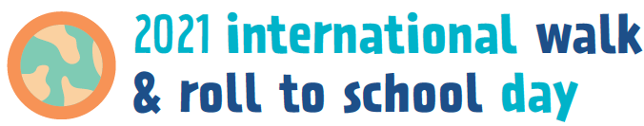
Event Photo
Credit: Alameda County Safe Routes to Schools Program
