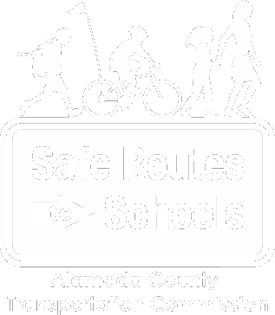

**ALAMEDA COUNTY SR2S**

**HIGH SCHOOL   
YOUTH TASK FORCE**

**Learn more at alamedacountysr2s.org**

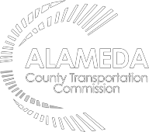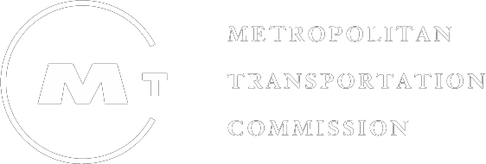

*The Alameda County Safe Routes to Schools Program is a program of the Alameda County Transportation Commission (alamedactc.org) and is funded with Alameda County’s local sales tax Measure B, regional, state and federal funds.*

**Get involved and make a difference with the Alameda County Safe Routes to School**

**High School Youth Task Force**

Meet students from high schools around Alameda County, learn together and plan walk, bike, carpool, and public transit events. The Safe Routes to Schools (SR2S) High School Youth Task Force is an extension of Alameda County’s SR2S High School program.  At least 2 student representatives from your high school serve on this countywide council to learn from their peers, plan fun activities, and discuss and , and give input to ensure that the SR2S program continues to be innovative and effective.

As members of the SR2S Youth Task Force, students will:

* Participate in quarterly meetings at locations near high schools enrolled in the program. Meetings are currently held by video.
* Serve as leaders at their schools.
* Help plan and evaluate SR2S work across the county.
* Learn how transportation choices affect climate change and air quality.
* Serve as representatives for at least one year.

In addition, you can receive community service hour credits while reducing your carbon footprint and creating positive change at your school and in your community.

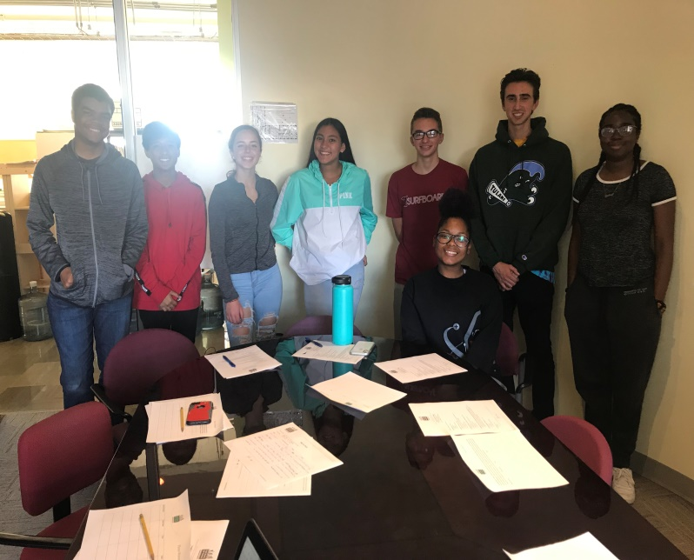

**To join the Youth Task Force or find out more information, contact Darrell Davis at**

[**ddavis@alamedacountysr2s.org**](mailto:ddavis@alamedacountysr2s.org)

