A big part of having a successful Walk and Roll to School Day is promotion. Students and parents need to know about the event in order to want to participate and feel comfortable with the event’s organization.

We recommend sending information out a week in advance of the event. Make sure you check with the editor of your school newsletter to see when they will need the information from you - it might be needed several weeks in advance.

In addition to sharing this information in the school newsletter, you also can follow up with announcements to students over the PA, remind parents via auto-call, post it on the school marquee, and/or get it on the agenda at parent meetings.

We have written the following text for you to customize for your specific school and event (easy peasy!). All the highlighted areas need to be customized before sending it to your newsletter editor.

Safe Routes to Schools Walk & Roll Day: Rail Safety

date

Students, parents, and teachers at [name of school] are ready to walk and roll! We will be hosting regular Walk and Roll to School Days [frequency - i.e. each month, every week] for the 2019-2020 school year. The [first/next/month] is on [date].

[Feel free to change this paragraph to best describe your activity!]

September is Rail Safety Month and a good time to learn the do’s and don’ts around trains and railroad tracks. Many students, parents, and school staff often cross the tracks near our school or on the way to or from school. Each time we do, we should ask ourselves, “Do I ACT Safely? Do I follow these three important rules?”

- Always look and listen for trains
- Cross only at designated railroad crossings
- Take your time – never race the train to the crossing or travel along the tracks

Our walk and roll event on [date] will feature rail safety using new materials available from the Alameda Safe Routes to School Rail Safety Website. We’ll have two of these once at school (both shown below): ACT Safely stickers for all participating and have a drawing for this poster that emphasize rail safety:
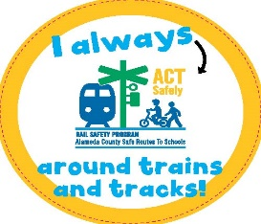
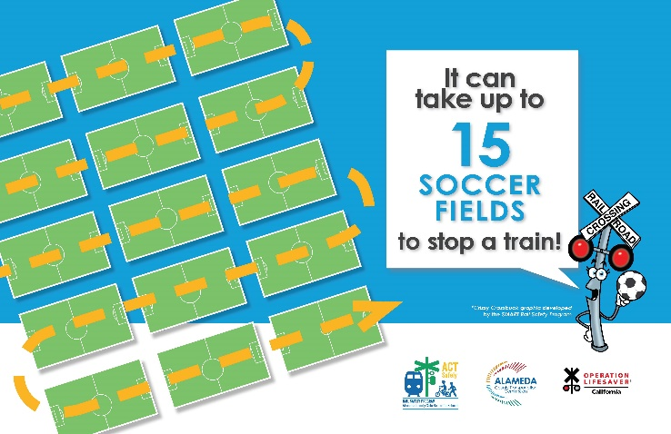

Once at school, other educational materials will be available including a brochure with more information on safety tips and rail safety resources. Click here for these resources. We know that parents can be great role models, so we’ll also have a one-page parents’ guide to rail safety. We hope you and your family will join the September Rail Safety Walk and Roll Day. This is a great opportunity to celebrate our health, the environment, and the safe habits we all need to practice!

DRAFT TEXT FOR SOCIAL MEDIA:
Facebook:
[ ] school will celebrate Rail Safety Month during our monthly walk and roll to school event on [day, date, time]. Contact [name or email address] for more information. Learn more about the Alameda County Safe Routes to Schools ACT Safely campaign at [website].

Twitter:
Join us for our September Walk and Roll to School Day event on [date] [day]. Contact [name or email address] for more information.

