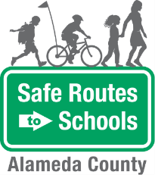Walking School Bus

Scenario Planning

|  |  |  |  |
| --- | --- | --- | --- |
| |  | | --- | | Scenario | | |  | | --- | | Route Leader response | |
| |  |  | | --- | --- | | |  | | --- | | Imagine a child in the walking school bus tripped and fell on the sidewalk. He has a scraped knee and is crying. | | |  |
| |  |  | | --- | --- | | |  | | --- | | There is one child in the walking school bus with a lot of energy. She continuously runs ahead of the bus. | | |  |
| |  |  | | --- | --- | | |  | | --- | | One of the children in the bus is not following proper walking safety rules. He runs out between parked cars and forgets to look left, right, then left again. | | |  |
| |  | | --- | | One day, on your normal route, you find construction has started that blocks the entire sidewalk. | |  |

|  |  |  |
| --- | --- | --- |
|  | Image result for metropolitan transportation commission, logo no background | *The Alameda County Safe Routes to Schools Program is funded by the Alameda County Transportation Commission (www.alamedactc.org). Your transportation dollars at work!* |