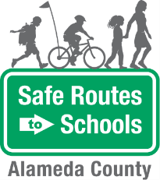
Bike Train
Scenario Planning

Scenario | Route Leader response
Imagine a child in the bike train hit a pothole and fell off his bike. He has a scraped elbow and is crying.

There is one child in the bike train with a lot of energy. She continuously bikes in circles around the other students in the train.

One of the children in the train is not following proper biking safety rules. He does not stop at stop signs and doesn’t communicate when he slows, stops or turns.

One day, on your normal route, you find construction has started that blocks the entire roadway.

The Alameda County Safe Routes to Schools Program is funded by the Alameda County Transportation Commission (www.alamedactc.org). Your transportation dollars at work!

