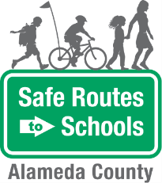
Walking School Bus
- EYE SPY: Allow children to pick an Eye Spy theme. Examples may include: Eye Spy safe things, Eye Spy dangerous things, Eye Spy things that pollute, and Eye Spy things that promote physical activity.  - ALPHABET GAME: “I’m going on a walk and I’m taking a _____.” Use the letters of the alphabet, A-Z, to think of things to take on your walk.  - LETTER OF THE DAY: Find 10 or 20 things on the way to school that start with the letter ___. Make it a competition between the leader and the children.  - CARPOOL COUNT: Count the number of cars with just one person in them and also the number of cars with more than one person in the vehicle.  - THEME DAYS: Children and adults can come up with themes that go along with each day of the week. For example, Mondays can be “yellow day” when everyone wears yellow; Tuesdays can be “rhyme time” when participants say as many words as they can think of that rhyme with a selected word; Wednesdays can be “sports day,” etc.  - NAME YOUR BUS: Name your walking school bus group. Solicit input from the students and ask them to vote.  - ANIMAL GAME: “I’m thinking of an animal that_____” (describe details about the animal).  - CREATE A JINGLE: Work with the kids to create a safety-themed song to the tune of a well-known song such as twinkle twinkle or Daniel Tiger’s theme song. | Questions? Contact:  Safe Routes to Schools at  info@alamedacountysr2s.org
Game Ideas

The Alameda County Safe Routes to Schools Program is funded by the Alameda County Transportation Commission (www.alamedactc.org). Your transportation dollars at work!

