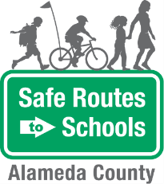
Bike Train
- THEME DAYS: Children and adults can come up with themes that go along with each day of the week. For example, Mondays can be “yellow day” when everyone wears yellow; Tuesdays can be “stripe day” when everyone wears stripes; Wednesdays can be “sports day,” etc.  - NAME YOUR BUS: Name your walking school bus group. Solicit input from the students and ask them to vote.  - HELMET DECORATING: Have a helmet-decorating party before beginning your Bike Train to get kids excited about wearing their helmets to school. | Questions? Contact:  Safe Routes to Schools at  info@alamedacountysr2s.org
Game Ideas

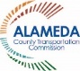 | 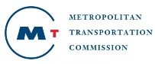 | The Alameda County Safe Routes to Schools Program is funded by the Alameda County Transportation Commission (www.alamedactc.org). Your transportation dollars at work!

