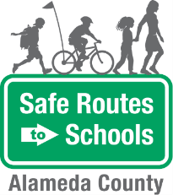
Walking School Bus
- BE ALERT. Look left, right, then left again before crossing the street. At a four-way intersection, look over your shoulder for cars that may be turning.  - LISTEN FOR ONCOMING CARS that may be behind a parked car, tree, or other obstacle.  - CROSS AT CORNERS or at a marked crosswalk. This is where drivers expect you.  - USE CROSSING SIGNALS CAREFULLY. If the intersection has a walk signal, push the button and wait for the walk signal. Before you cross, check that all drivers have stopped, especially those turning right.  - USE EYE CONTACT and hand signals to communicate before crossing. Don’t assume driver see you.  - FOLLOW DIRECTIONS from crossing guards and safety patrols.  - USE A SIDEWALK WHEN AVAILABLE. If there’s no sidewalk, walk on the road facing oncoming traffic.  - WALK WITH AN ADULT, other students, or a buddy, particularly if you are a younger student  - DRESS TO BE SEEN. Bright colors are more visible during the day, and light colors are more visible in the evening or at night. Reflective clothing is always a good idea, too! | Questions? Contact:  Safe Routes to Schools at  info@alamedacountysr2s.org
Safety Tips

The Alameda County Safe Routes to Schools Program is funded by the Alameda County Transportation Commission (www.alamedactc.org). Your transportation dollars at work!

