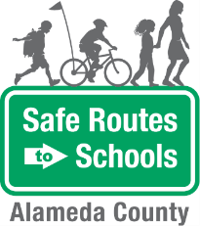
Bike Train
Volunteer Agreement

Parent Name: __________________________________  Parent Phone Number: __________________________  Parent Email: __________________________________  Preferred way to be reached: ________________________ | Today’s Date: ___________________________________  School: _________________________________________  Are you interested in being a (circle one):  Route Leader Volunteer

I agree to the following expectations:
- TRAINING. Attend a Bike Train volunteer training.
- BE ON TIME. Be on time to join my assigned Bike Train.
- ASSIST THE ROUTE LEADER. Help the Route Leader manage the students along the route.
- MODEL SAFE BIKING BEHAVIOR. Model appropriate biking behavior, following the rules of the road and practicing guides such as “look left, look right, and look left again” before crossing an intersection.
- COMMUNICATE. Inform my Bike Train Leader if I am unable to attend my designated Bike Train or if I am running late

I have read and understood the expectations of a volunteer and agree to follow these rules. Please return to the school office.

Volunteer Signature: ___________________________________________________________________

The Alameda County Safe Routes to Schools Program is funded by the Alameda County Transportation Commission (www.alamedactc.org). Your transportation dollars at work!

