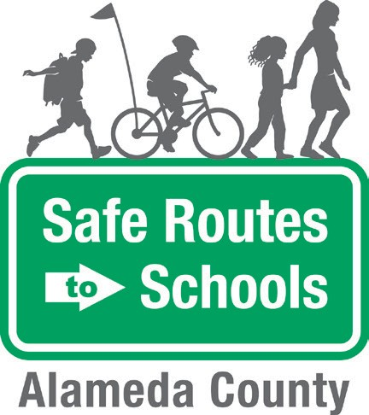
Walking School Bus
Student Participation Form

Parent Name: Student Name Parent Phone Number: Parent Email: Preferred way to be reached:
Today’s Date: School: Grade: Classroom:

Before you join us on a Walking School Bus, please review the following rules and expectations with your family. Walking School Buses can be a fun and safe way to get to school if you follow these simple rules! Your Route Leader will give you a warning if you forget any of these rules. If the behavior persists, the Route Leader will alert the school and your family.

I agree to the following expectations:

BE ON TIME. Be on time to join my assigned Walking School Bus.
STAY WITH THE GROUP. Walk behind the Route Leader in the front and in front of the Leader in the back.
STOP AND WAIT AT INTERSECTIONS. At street corners or stop signs, wait for the group and then look left, look right, and look left again before crossing.
FOLLOW DIRECTIONS. Always listen to your Route Leaders and don’t run or take off at any time.
BE AWARE. Pay attention to car traffic at driveways and intersections; don’t play with toys or electronic devices while you walk.
BE RESPECTFUL. Be considerate of other students, the neighborhood, and neighbors.

I have read and understood the expectations of a participant in the Walking School Bus and agree to follow these rules. Please return to the school office.

Student Signature: Parent/Guardian Signature:

