Join the
Walking School Bus

at XX Elementary
A Walking School Bus (WSB) is a group of students walking to and/or from school with trusted adults. A WSB improves children’s safety by walking in a supervised group and it saves parents time and money by sharing the responsibility of taking kids to school.

We have two tentative routes planned for the Walking School Bus - the yellow route and the blue route (see the map on the back). We anticipate that the Walking School Bus will happen once a month, starting in February 2018.

Are you interested in leading a Walking School Bus route, volunteering, or having your child participate? Fill out the form below!

Questions? E-mail info@alamedacountysr2s.org

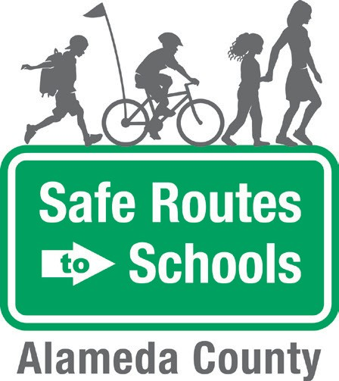

Contact Us
info@alamedacountysr2s.org

The Alameda County Safe Routes to Schools Program is funded by the Alameda County Transportation Commission (www.alamedactc.org). Your transportation dollars at work!

PLEASE fill out and return this form to the Main Office.

- Are you interested in volunteering for the Walking School Bus? If so, which route? (see map on back).
Yellow Route Blue Route No

- Is your child interested in participating in a Walking School Bus? (see map on back).
Yellow Route Blue Route No

Parent or Caregiver Name: Student(s) Name(s):
Phone Number: Email:
Home Address
(or nearby intersection):

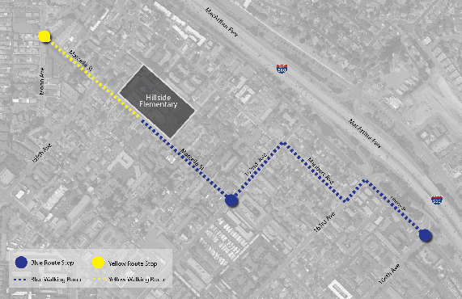
Tentative Walking School Bus Routes

