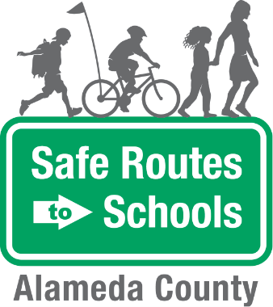
Join the
Bike Train
at XXXX Elementary
A Bike Train is a group of students biking to and/or from school with trusted adults. A Bike Train improves children’s safety by biking in a supervised group and it saves parents time and money by sharing the responsibility of taking kids to school.  We have two tentative routes planned for the Bike Train - the yellow route and the blue route (see the map on the back). We anticipate that the Bike Train will happen once a month, starting in February 2018.  Are you interested in leading a Bike Train route, volunteering, or having your child participate? Fill out the form below!  Questions? Please email info@alamedacountysr2s.org | Contact Us  At info@alamedacountysr2s.org

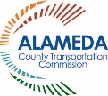 | 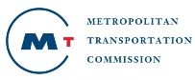 | The Alameda County Safe Routes to Schools Program is funded by the Alameda County Transportation Commission (www.alamedactc.org). Your transportation dollars at work!
------------------------------------------------------------------------------------------------------------------------------
PLEASE fill out and return this form to the Main Office.

1. Are you interested in volunteering for the Bike Train? If so, which route?
(see map on back). Yellow Route ____ Blue Route _____ No _____
2. Is your child interested in participating in a Bike Train? If so, which route?
(see map on back). Yellow Route ____ Blue Route _____ No _____
Parent or Caregiver Name: ______________________________________________________________
Student(s) Name(s): ___________________________________________________________________
Phone Number: ________________________________________________________________________
Email: ________________________________________________________________________________
Home Address (or nearby intersection): __________________________________________________

Tentative Bike Train Routes
