Sly Fox and Birdie.
Video Facilitation Guide
For Teachers to distribute to parents
Audience: Pre-Kindergarten – 3rd Grade
Materials: Sly Fox and Birdie video, plus paper and crayons/markers if you’re going to have students do the drawing activity at the end.
Background Information: Sly Fox and Birdie is a 10-minute cartoon that teaches children to be extremely cautious around railroad tracks. It was created to entertain as well as educate children.
Getting Started
Introduction: Today I’m going to share a cartoon with you about how to be safe around trains.
Action: Send students/parents the Sly Fox and Birdie video.
After Viewing
Have students answer a few short questions to test comprehension
- What was one thing you learned from the video?
- What could happen if you put things on the railroad tracks?
- Should you ever walk on the railroad tracks?
- Why is it dangerous to stand near the railroad tracks?
- What do gates, red lights, and bells mean at a railroad crossing?
Send summary of Key Points in video.
1. Do not cross bridge or tunnels with railroad tracks 2. Never walk, play or sit on tracks
3. Always stay off tracks
4. Do not play on box cars or around box cars
5. Do not play with objects on the tracks.
When it comes to railroad tracks, remember: Look, Listen and Live! Stay Off! Stay Away! Stay Alive!
Have the children draw safety picture/posters

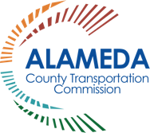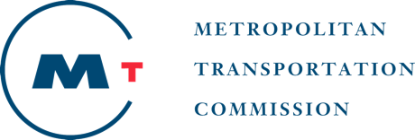
The Alameda County Safe Routes to Schools Program is a program of the Alameda County Transportation Commission (alamedactc.org) and is funded with Alameda County’s local sales tax Measure B, regional, state and federal funds.

