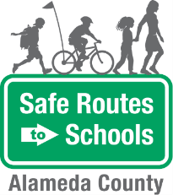
Walking School Bus
Scenario Planning

Scenario | Route Leader response
Imagine a child in the walking school bus tripped and fell on the sidewalk. He has a scraped knee and is crying. | - Assess the situation: can child still walk to school with group? Or, does one route leader stay behind with the child to seek appropriate medical attention.
There is one child in the walking school bus with a lot of energy. She continuously runs ahead of the bus. | - Remind her the importance of staying with the group and give her a task: help lead the younger students, start off a game of eye spy, etc.  - If she is continually running ahead of the group, warn her that you will have to talk to her parents.
One of the children in the bus is not following proper walking safety rules. He runs out between parked cars and forgets to look left, right, then left again. | - Remind him of the rules of a safe walking and potentially start playing a game to get him involved with the group.  - Warn student that you will have to contact his parents if he continues to not follow proper walking safety rules.  - It is up to the discretion of the Route Leader to determine if the student cannot safely walk to school with other students in the WSB
One day, on your normal route, you find construction has started that blocks the entire sidewalk. | - Assess the road. If it seems like low volume of cars, you may carefully walk students on the road facing oncoming traffic.  - If the road is too busy, turn around and either look for a crosswalk to cross to the other side of the street, or use a nearby street for an alternate route.

The Alameda County Safe Routes to Schools Program is funded by the Alameda County Transportation Commission (www.alamedactc.org). Your transportation dollars at work!

