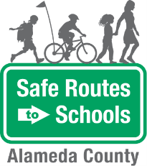
Bike Train
- WEAR YOUR HELMET. Always wear a properly-fitted helmet. No helmet, no ride.  - KNOW YOUR SKILLS. Be able to start and stop smoothly, ride in a straight line without weaving, and use hand signals while maintaining your balance.  - CHECK YOUR BIKE. Before riding, make sure your tires have enough air, your brakes work and your pedals spin smoothly. Take a test ride to make sure everything works well.  - GO WITH THE FLOW. Always ride in the street going the same direction as traffic — never against.  - AVOID THE DOOR ZONE. When riding near parked cars, stay 3-5 feet away in order to avoid hitting open car doors.  - TAKE THE LANE. Where the lane is too narrow to share safely with a car, feel free to ride in the center of the travel lane. It’s safer for you and people driving.  - RIDE SINGLE FILE. Leave space between you and the person in front of you in case of a sudden stop.  - STOP AT SIGNS AND LIGHTS. Always come to a full stop at stop signs or red lights. Only proceed when it is safe or the light turns green.  - PEOPLE WALKING HAVE THE RIGHT OF WAY. Always yield to your friends on foot.  - COMMUNICATE. Use hand signals to indicate turns, slowing and stopping. Calling out “slowing,” “turning,” or “stopping” can also be helpful when riding in a group.  - DRESS TO BE SEEN. Bright colors are more visible during the day, and light colors are more visible in the evening or at night. Reflective clothing is always a good idea, too!  - BRING YOUR LOCK. Always use a hardened steel U-lock to secure your bicycle once at school. Attach the frame and front wheel of the bike to the bike rack. | Questions? Contact:  Safe Routes to Schools at  info@alamedacountysr2s.org
Safety Tips

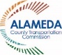 | 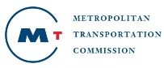 | The Alameda County Safe Routes to Schools Program is funded by the Alameda County Transportation Commission (www.alamedactc.org). Your transportation dollars at work!

