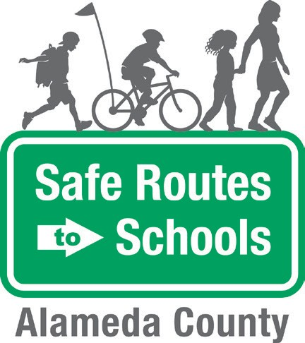
Walking School Bus
Volunteer Agreement

Parent Name: Phone Number: Email: Preferred way to be reached:
Today’s Date: School:
Are you interested in being a (circle one): Route Leader Volunteer

I agree to the following expectations:

TRAINING. Attend a Walking School Bus volunteer training.
BE ON TIME. Be on time to join my assigned Walking School Bus.
ASSIST THE ROUTE LEADER. Help the Route Leader manage the students along the route.
MODEL SAFE WALKING BEHAVIOR. Model appropriate walking behavior, following the rules of the road and practicing guides such as “look left, look right, and look left again” before crossing the street.
COMMUNICATE. Inform my Walking School Bus Route Leader if I am unable to attend my designated Walking School Bus of if I am running late.

I have read and understood the expectations of a volunteer and agree to follow these rules. Please return to the school office.

Volunteer Signature:

