Join other families and students walking to school
Únete a otras familias y estudiantes caminando a escuela
Walking School Bus

WHO? Students, Route Leaders, and Volunteers QUIÉN? Estudiantes y padres que auiren ser líderes

WHAT? A Walking School Bus is a group of students walking or biking to and from school with friends and trusted adults.
QUÉ? Un autobús escolar caminante es un grupo de que caminan a y de escuela con padres que sirven como guías estudiantes
WHEN? Beginning fall 2017 for the 2017-18 school year.
¿CUÁNDO? Empezando otoño de 2017 para el año escolar 2017-18
WHY? Have fun with friends, exercise, explore outdoor activity, and save the planet!
¿POR QUÉ? Diviértete con tus amigos, haz ejercicio, explora actividades afuera y salva el planeta

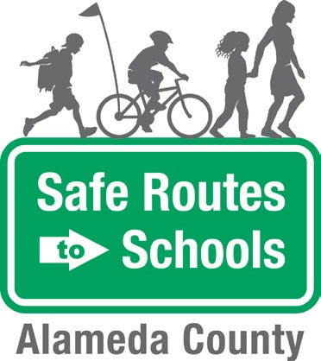
Questions? Contact:
E-mail Safe Routes to Schools at info@alamedacountysr2s.org

The Alameda County Safe Routes to Schools Program is funded by the Alameda County Transportation Commission (www.alamedactc.org). Your transportation dollars at work!

Are you interested in participating as a Route Leader or Volunteer?
¿Esta interesado en participar como guia/lider de un Autobús Escolar Caminante?
Yes/ SÍ No

Is your child interested in participated in a Walking School Bus ?
¿Crees que su hijo/hija esta interesado en participar en un Autobús Escolar Caminante?
Yes/ SÍ No

Parent Name: Phone Number:

