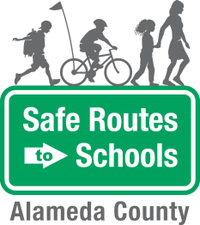
Additional Resources

Get the Word Out! Template Text for Your School Newsletter
Promoting your event is a big part of its success. Your students and parents need to know about the event in order to participate, so use two or three avenues that reach students and parents, starting with the school newsletter.
Consider using the following text to include in your school newsletter at least one week in advance of the event. Check with the editor of your school newsletter to see when they will need the content, as the lead time may be several weeks. Before submitting to the newsletter, replace the yellow highlighted fields in the sample text below with details of your event, making sure to note important safety information.
After publishing in the school newsletter, follow up with announcements to students over the PA and remind parents about the event via the auto-call, school marquee, and/or at parent meetings.

Alameda County Safe Routes to Schools Ongoing Walk and Roll Day for May

date
The students, parents, and teachers at [name of school] are encouraged to participate in our [first/next] [frequency - i.e. each month, every week] Walk and Roll to School Day event on [date]. Supervised by adults or older students, the event offers a safe way for students to walk, bike, scooter, or skate to school with their friends. Benefits includes physical activity, classroom readiness, socialization, and just plain fun.
[optional theme and activity] The May theme is: Bike to School Month!
Come visit the welcome station when you get to school! We will have a helmet decorating station where students can customize helmets with arts and crafts supplies. Who doesn’t like a helmet done exactly the way you want? We’ll also have a helmet-fitting stand for students to see if their helmet fits properly. Stop on by even if you don’t have a helmet! We will have an activity for everyone.

